Executive Summary

ES-05 Executive Summary - 24 CFR 91.200(c), 91.220(b)
1. Introduction
Minot, North Dakota, receives an annual entitlement allocation from the U.S. Department of Housing and Urban Development’s (HUD) Community Development Block Grant (CDBG) program. The Consolidated Plan provides direction on the investment of CDBG dollars over five years, from 2024 – 2028. Additionally, each year, the City will produce an Annual Action Plan that details how the City will carry out the goals and objectives identified in this Plan.
2024 marks the FIRST year for the City of Minot as an Entitlement Community with the U.S. Department of Housing and Urban Development.
HUD provides a broad range of eligible activities that can be utilized with CDBG funding. A key feature of these grants is the City's ability to choose how to use the funds. The City must determine which eligible activities will best serve the community's needs. HUD requires grantees to develop a Five-Year Consolidated Plan to determine the most pressing needs and effective, place-based market-driven strategies to meet those needs.
When developing a Consolidated Plan, the City must first analyze Minot's needs and then propose strategies to meet those needs. The Consolidated Plan and first-year Action Plan (2024) format is highly prescriptive, with many data points already populated into the HUD-provided template.
The Consolidated Plan and first-year Action Plan has the following parts:
- ES - Executive Summary
- PR – The Process
- NA - Needs Assessment
- MA - Market Analysis
- SP - Strategic Plan
- AP – Annual Action Plan 2024
The Housing Needs Assessment (NA) and Housing Market Analysis (MA) outline levels of relative need in affordable housing, homelessness, special needs, and community development. This information is gathered through several methods, including consultation with local agencies, public outreach, a review of demographic and economic data sets, and a housing market analysis.
The Strategic Plan (SP) details how the City will address its priority needs and utilize funding over the next five years. The strategies must reflect the current market condition, expected funding availability, and local capacity to administer the plan. The Annual Action Plan (AAP) describes funding and projects in 2024 and gives a more specific look into how the program will operate.
Consistent with HUD's mission, the City works to support community development priorities and increase access to affordable housing free from discrimination. The City will embrace a high standard of ethics, management, and accountability in undertaking this work. The City will continue to form new partnerships that leverage resources and improve HUD's effectiveness at the community level.
2. Summary of the objectives and outcomes identified in the Plan Needs Assessment Overview
Minot’s 2024-2028 Consolidated Plan is a five-year strategic plan that provides an outline of actions for the community as it works toward meeting the housing and community development needs of its low—and moderate-income and special-needs households. The plan's development includes a profile of the community and its economy, assessing housing and community development needs, and developing long-range strategies to meet those needs.
The Consolidated Plan serves the following functions:
- A planning document for the City, which builds on a participatory process among citizens, organizations, businesses, and other stakeholders;
- A submission for federal funds under HUD’s formula grant program for jurisdictions;
- A strategy to be followed in carrying out HUD programs; and
- A management tool for assessing performance, tracking success, and determining the course of future Consolidated Plans.
The Consolidated Plan for the fiscal years 2024-2028 was prepared in accordance with Sections 91.100 through 91.230 of HUD's Consolidated Plan Final Rule.
Below are the HUD objectives and the City's projected outcomes over the 5-year Consolidated Plan:
- Provide decent housing by preserving the affordable housing stock, increasing the availability of affordable housing, reducing discriminatory barriers, increasing the supply of supportive housing for those with special needs, and transitioning homeless persons and families into housing.
- Provide a suitable living environment through safer, more livable neighborhoods, greater integration of LMI residents throughout Minot, increased housing opportunities, and reinvestment in LMI neighborhoods.
- Expand economic opportunities through targeted public services, homeownership opportunities, development activities that promote long-term community viability, and the empowerment of low- and moderate-income persons to achieve self-sufficiency.
During the 2024-2028 Consolidated Plan period, the City of Minot will have projects that help to support affordable housing for low- to moderate-income residents.
- Rental units rehabilitated -
- Homeowner housing added -
- Homeowner housing rehabilitated -
Other programs will help support low- and moderate-income residents.
- Homeless overnight shelter - cultivate local partners and support development of a year round low-barrier shelter
- Public Facilities and Infrastructure projects - 2,500 persons assisted
- Public services - 4,175 persons assisted

3. Evaluation of past performance
2024 is the City of Minot's first year to receive HUD CDBG funds as an entitlement community.
4. Summary of citizen participation process and consultation process
Citizen participation includes actively encouraging citizens, particularly the low and moderate-income population, to participate in the planning process for the five-year Consolidated Plan, the Annual Action Plan, the submission of Substantial Amendments, and the development of the Consolidated Annual Performance Report (CAPER).
The City encouraged and sought broad participation but especially encouraged participation from low- and moderate-income persons, residents of predominantly low- and moderate-income neighborhoods, minorities, non-English speaking persons, persons with disabilities, public housing residents, local and regional institutions, businesses, developers, and nonprofit organizations.
All public meetings are held in a location convenient to residents, particularly those that are potential or actual beneficiaries. Meetings are held at times to provide maximum flexibility for an array of citizen schedules. Attention is given to ensure meeting times increase the probability of maximum citizen participation.
Citizen participation played a vital role in the needs assessment, market analysis, and the construction of the goals and priorities featured in the Consolidated Plan. The City distributed a survey to residents to gather input on a broad housing needs assessment, and results were utilized to develop this plan.
All Public Hearings and Comment Periods are advertised in the local newspaper of general circulation. The City held a 30-day comment period from XXXXXXXXXXX
The City of Minot had two public hearings, widely distributed a community needs survey and met with key stakeholders in the community.
5. Summary of public comments
Citizen participation includes actively encouraging citizens, particularly the low and moderate-income population, to participate in the planning process for the five-year Consolidated Plan, the Annual Action Plan, the submission of Substantial Amendments, and the development of the Consolidated Annual Performance Report (CAPER).
Citizen participation played a vital role in the needs assessment, market analysis, and the construction of the goals and priorities featured in the Consolidated Plan.
6. Summary of comments or views not accepted and the reasons for not accepting them
Minot accepts and records all comments. All comments and results from public meetings were recorded and utilized to help form the priorities, goals, and activities for the Consolidated Plan.
7. Summary
Minot has an adopted Citizen Participation Plan (CPP) implemented in conjunction with the Annual Action Plan. The CPP provides the framework for public input into the allotment of CDBG funds granted to the City. Minot's CPP guides how it gives notice and outreach to residents for public hearings regarding all aspects of the CDBG process.

The Process

PR-05 Lead & Responsible Agencies 24 CFR 91.200(b)
1. Describe agency/entity responsible for preparing the Consolidated Plan and those responsible for administration of each grant program and funding source
The following are the agencies/entities responsible for preparing the Consolidated Plan and those responsible for administration of each grant program and funding source.
Agency Role | Name | Department/Agency
Lead Agency | MINOT

CDBG Administrator
Table 1 – Responsible Agencies

Narrative
Consolidated Plan Public Contact Information

PR-15 Citizen Participation – 91.105, 91.115, 91.200(c) and 91.300(c)
1. Summary of citizen participation process/Efforts made to broaden citizen participation
Summarize citizen participation process and how it impacted goal-setting

Citizen participation includes actively encouraging citizens, particularly the low and moderate-income population, to participate in the planning process for the five-year Consolidated Plan, the Annual Action Plan, the submission of Substantial Amendments, and the development of the Consolidated Annual Performance Report (CAPER). All notices of public meetings relating to this process are published in the local newspaper before the public meeting. According to HUD guidelines, the Consolidated Plan and first-year Action Plan draft was posted on the City's website, made known to grant subrecipients, and noticed in the local newspaper.
The City encouraged and sought broad participation but especially encouraged participation from low- and moderate-income persons, residents of predominantly low- and moderate-income neighborhoods, minorities, non-English speaking persons, persons with disabilities, public housing residents, local and regional institutions, businesses, developers, nonprofit organizations, philanthropic organizations, and community or faith-based organizations.
All public meetings are held in a location convenient to residents, particularly those who are potential beneficiaries. Meetings are held at times to provide maximum flexibility for an array of citizen schedules. Attention is given to ensure meeting times increase the probability of full citizen participation.
Additionally, the Consolidated Plan and Action Plan can be made available in Spanish upon request. All Public Hearings and Comment Periods are advertised in the local newspaper of general circulation.

Citizen Participation Outreach
Sort Order | Mode of Outreach | Target of Outreach | Summary of  response/attendance | Summary of  comments received | Summary of comments not accepted and reasons | URL (If applicable)
Table 4 – Citizen Participation Outreach

Needs Assessment

NA-05 Overview
Needs Assessment Overview
The Needs Assessment (NA) of the Consolidated Plan provides a profile of the City's population, median income, household demographics, housing problems, cost burden, and crowding. HUD Comprehensive Housing Affordability Strategy (CHAS), American Community Survey (ACS), and Census data were used to help assess the City's priority needs, which will form the basis for the Strategic Plan and the activities that will be supported with CDBG funding.
A key goal of the Needs Assessment is to identify the nature and extent of housing problems experienced by Minot's residents. The Needs Assessment takes particular care to address "disproportionately greater need" for housing, severe housing problems, and housing cost burden. A disproportionately greater need exists when the members of a racial or ethnic group at a given income level experience housing problems at a greater rate (10% points or more) than the income level as a whole.

NA-10 Housing Needs Assessment - 24 CFR 91.205 (a,b,c)
Summary of Housing Needs
The Housing Needs Assessment relies heavily on prepopulated tables provided by HUD to entitlement communities. The data sets utilized are primarily CHAS, ACS, and HUD-adjusted median family incomes (HAMFI).
Comprehensive Housing Affordability Strategy (CHAS)
1990, Congress passed the National Affordable Housing Act, which required that State and local governments participating in selected HUD grant programs prepare a Comprehensive Housing Affordability Strategy (CHAS). The CHAS was meant to serve as the strategic guide for housing and community development activities, particularly activities funded by HUD grants and targeted to low- and moderate-income households.
To support this analysis, HUD and the Census Bureau produced custom tabulations of the 1990 Census that provided grantees with information about low- and moderate-income households' housing needs. As a planning document, the CHAS was superseded in 1995 by the Consolidated Plan, but the Census data's custom tabulations continue to be known as the "CHAS data." The CHAS data were updated following the Census 2000, and in 2009 they were updated to rely on the American Community Survey (ACS), the Census Bureau's new annual survey that replaced the long form of the decennial Census. The CHAS data combine ACS microdata with HUD-adjusted median family incomes (HAMFI) to estimate the number of households that qualify for HUD assistance. The CHAS data also incorporate household characteristics (race/ethnicity, age, family size, disability status) and housing unit characteristics (such as the number of bedrooms and rent/owner costs).
HUD-Adjusted Median Family Incomes (HAMFI)
If the terms "area median income" (AMI) or "median family income" (MFI) are used in the CHAS, assume it refers to HAMFI. This is the median family income calculated by HUD for each jurisdiction to determine Fair Market Rents (FMRs) and HUD programs' income limits. HAMFI will not necessarily be the same as other calculations of median incomes (such as a simple Census number) due to a series of adjustments that are made.
The Community Housing Affordability Strategy (CHAS) evaluates the conditions of families in the lower 50% of the Housing Affordability Median Income for the area.
Income Category
- Extremely low-income 30% HAMFI
- Very low-income >30% - 50% HAMFI
- Low income >50% - 80% HAMFI
- Low- and middle-income <100% HAMFI
- Upper income >100% HAMFI
The most relevant income category is 80% of HAMFI because most HUD programs base eligibility on this threshold, generally referred to as low- to moderate-income.
US Census estimated the population of Minot to be 46,195 in 2009 and 47,835 persons as of 2020, the most recent data (V2020). Minot's population grew by only 4% over that period compared to a population increase of 6.3% nationwide.
Demographics | Base Year: 2009 | Most Recent Year: 2020 | % Change
Population | 46,195 | 47,835 | 4%
Households | 18,780 | 21,155 | 13%
Median Income | $60,721.00 | $64,401.00 | 6%
Table 5 - Housing Needs Assessment Demographics

Data Source: | 2000 Census (Base Year), 2016-2020 ACS (Most Recent Year)

Number of Households Table
 | 0-30% HAMFI | >30-50% HAMFI | >50-80% HAMFI | >80-100% HAMFI | >100% HAMFI
Total Households | 3,130 | 2,445 | 4,755 | 2,500 | 8,325
Small Family Households | 520 | 425 | 1,310 | 1,055 | 4,405
Large Family Households | 105 | 55 | 385 | 145 | 715
Household contains at least one person 62-74 years of age | 545 | 435 | 590 | 345 | 1,635
Household contains at least one person age 75 or older | 525 | 450 | 450 | 265 | 350
Households with one or more children 6 years old or younger | 545 | 305 | 745 | 290 | 1,045

Table 6 - Total Households Table
Data Source: | 2016-2020 CHAS

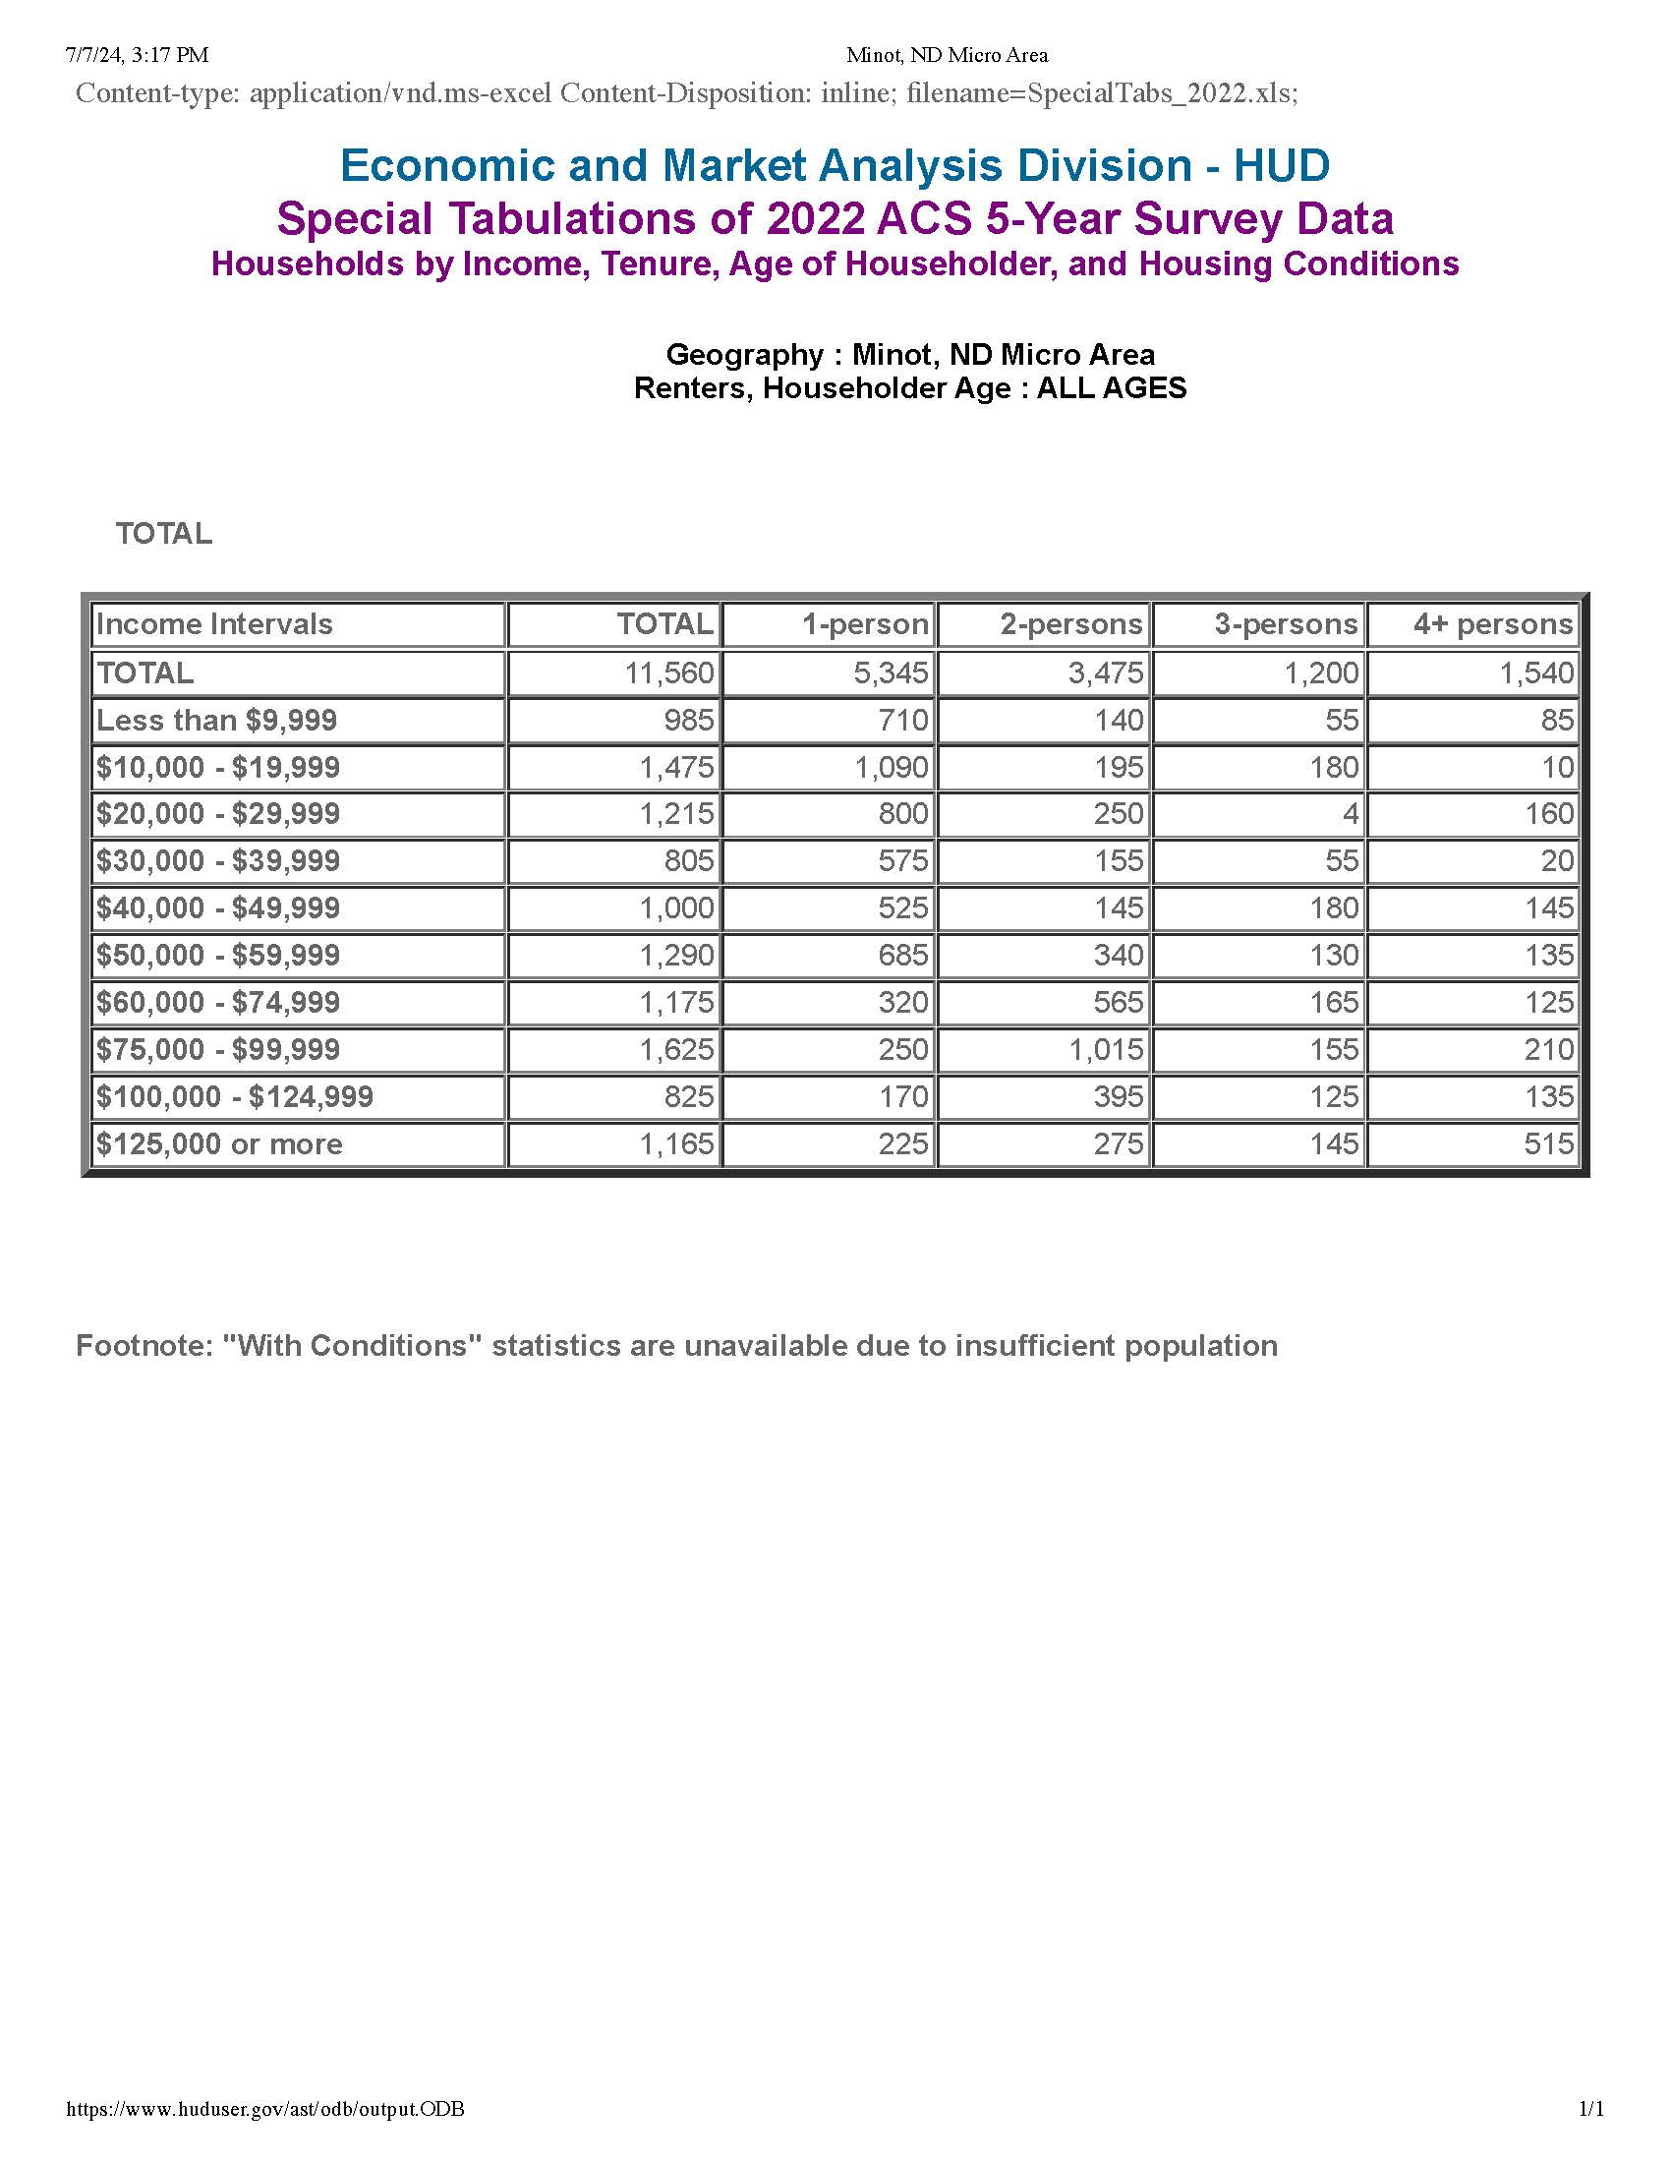
Renters by income

Housing Needs Summary Tables
1. Housing Problems (Households with one of the listed needs)
 | Renter |  |  |  |  | Owner
 | 0-30% AMI | >30-50% AMI | >50-80% AMI | >80-100% AMI | Total | 0-30% AMI | >30-50% AMI | >50-80% AMI | >80-100% AMI | Total
NUMBER OF HOUSEHOLDS
Substandard Housing - Lacking complete plumbing or kitchen facilities | 70 | 55 | 0 | 0 | 125 | 0 | 0 | 25 | 0 | 25
Severely Overcrowded - With >1.51 people per room (and complete kitchen and plumbing) | 20 | 55 | 15 | 10 | 100 | 0 | 0 | 0 | 0 | 0
Overcrowded - With 1.01-1.5 people per room (and none of the above problems) | 50 | 0 | 85 | 0 | 135 | 20 | 25 | 145 | 15 | 205
Housing cost burden greater than 50% of income (and none of the above problems) | 1,585 | 110 | 25 | 55 | 1,775 | 415 | 240 | 95 | 10 | 760
Housing cost burden greater than 30% of income (and none of the above problems) | 295 | 745 | 310 | 45 | 1,395 | 120 | 200 | 520 | 135 | 975
Zero/negative Income (and none of the above problems) | 175 | 0 | 0 | 0 | 175 | 35 | 0 | 0 | 0 | 35
Table 7 – Housing Problems Table
Data Source: | 2016-2020 CHAS

2. Housing Problems 2 (Households with one or more Severe Housing Problems: Lacks kitchen or complete plumbing, severe overcrowding, severe cost burden)
 | Renter |  |  |  |  | Owner
 | 0-30% AMI | >30-50% AMI | >50-80% AMI | >80-100% AMI | Total | 0-30% AMI | >30-50% AMI | >50-80% AMI | >80-100% AMI | Total
NUMBER OF HOUSEHOLDS
Having 1 or more of four housing problems | 1,730 | 220 | 125 | 65 | 2,140 | 430 | 265 | 260 | 25 | 980
Having none of four housing problems | 780 | 1,300 | 2,330 | 1,060 | 5,470 | 195 | 660 | 2,035 | 1,355 | 4,245
Household has negative income, but none of the other housing problems | 0 | 0 | 0 | 0 | 0 | 0 | 0 | 0 | 0 | 0
Table 8 – Housing Problems 2
Data Source: | 2016-2020 CHAS

3. Cost Burden > 30%
 | Renter |  |  |  | Owner
 | 0-30% AMI | >30-50% AMI | >50-80% AMI | Total | 0-30% AMI | >30-50% AMI | >50-80% AMI | Total
NUMBER OF HOUSEHOLDS
Small Related | 370 | 110 | 40 | 520 | 15 | 165 | 245 | 425
Large Related | 65 | 25 | 45 | 135 | 20 | 4 | 80 | 104
Elderly | 455 | 220 | 15 | 690 | 375 | 200 | 135 | 710
Other | 1,080 | 600 | 245 | 1,925 | 140 | 65 | 180 | 385
Total need by income | 1,970 | 955 | 345 | 3,270 | 550 | 434 | 640 | 1,624
Table 9 – Cost Burden > 30%
Data Source: | 2016-2020 CHAS

4. Cost Burden > 50%
 | Renter |  |  |  | Owner
 | 0-30% AMI | >30-50% AMI | >50-80% AMI | Total | 0-30% AMI | >30-50% AMI | >50-80% AMI | Total
NUMBER OF HOUSEHOLDS
Small Related | 0 | 0 | 0 | 0 | 15 | 90 | 0 | 105
Large Related | 0 | 0 | 0 | 0 | 20 | 4 | 0 | 24
Elderly | 405 | 135 | 0 | 540 | 320 | 90 | 15 | 425
Other | 0 | 895 | 20 | 915 | 75 | 0 | 0 | 75
Total need by income | 405 | 1,030 | 20 | 1,455 | 430 | 184 | 15 | 629
Table 10 – Cost Burden > 50%
Data Source: | 2016-2020 CHAS

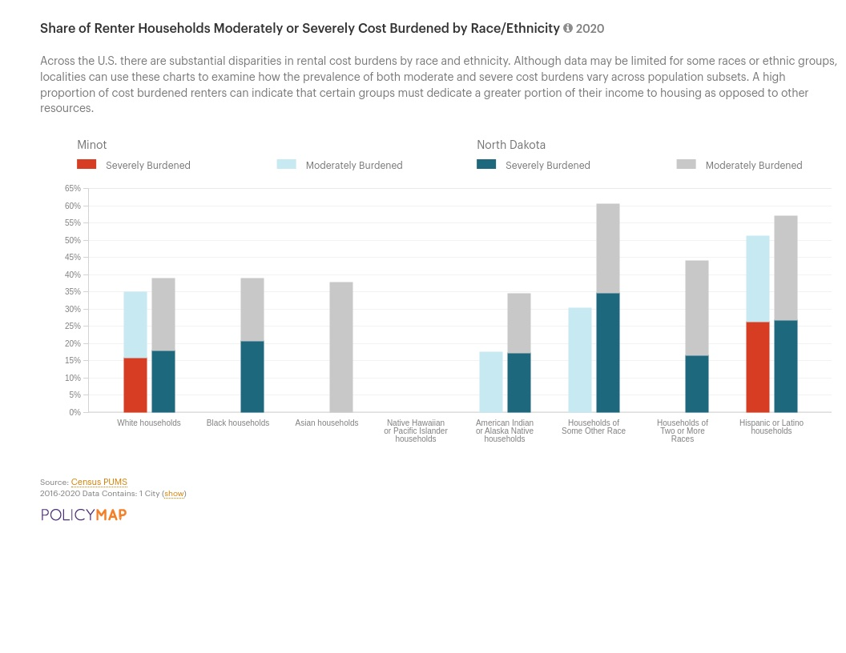
Cost Burdened Renters by Race/Ethnicity
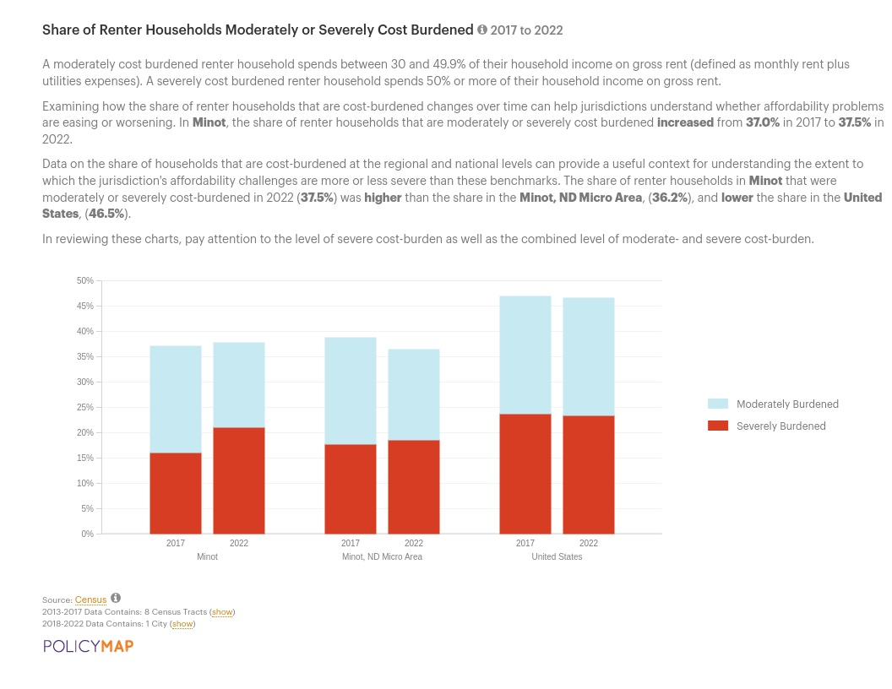
Cost Burdened Renters
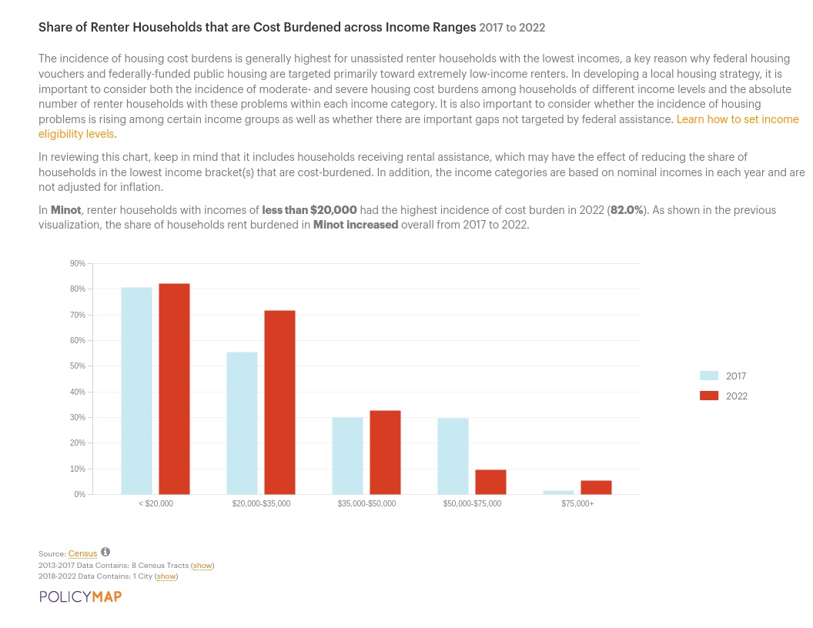
Cost Burdened Renters by Income
5. Crowding (More than one person per room)
 | Renter |  |  |  |  | Owner
 | 0-30% AMI | >30-50% AMI | >50-80% AMI | >80-100% AMI | Total | 0-30% AMI | >30-50% AMI | >50-80% AMI | >80-100% AMI | Total
NUMBER OF HOUSEHOLDS
Single family households | 54 | 100 | 85 | 10 | 249 | 20 | 25 | 135 | 15 | 195
Multiple, unrelated family households | 0 | 0 | 0 | 0 | 0 | 0 | 0 | 10 | 0 | 10
Other, non-family households | 15 | 0 | 15 | 0 | 30 | 0 | 0 | 0 | 0 | 0
Total need by income | 69 | 100 | 100 | 10 | 279 | 20 | 25 | 145 | 15 | 205
Table 11 – Crowding Information – 1/2
Data Source: | 2016-2020 CHAS

 | Renter |  |  |  | Owner
 | 0-30% AMI | >30-50% AMI | >50-80% AMI | Total | 0-30% AMI | >30-50% AMI | >50-80% AMI | Total
Households with Children Present | 0 | 0 | 0 | 0 | 0 | 0 | 0 | 0
Table 12 – Crowding Information – 2/2

Data Source Comments:

Describe the number and type of single person households in need of housing assistance.
In 2022, there were 2,362 studio or 1-bedroom units (25.7% of all rented units) and 15,025 one-and two-person households in Minot (71.0% of all households).

Single-person renter households in Minot have a statistically greater chance of having LMI than other household sizes.
Approx. 75% of single-person renter households in the Minot Micro Area are considered LMI. 50% of single-person renter households in the same area would be considered low-income.
Estimate the number and type of families in need of housing assistance who are disabled or victims of domestic violence, dating violence, sexual assault and stalking.
Disability
Federal nondiscrimination laws define a person with a disability to include any (1) individual with a physical or mental impairment that substantially limits one or more major life activities; (2) individual with a record of such impairment; or (3) individual who is regarded as having such an impairment.
In general, a physical or mental impairment includes, but is not limited to, examples of conditions such as orthopedic, visual, speech, and hearing impairments, cerebral palsy, autism, epilepsy, muscular dystrophy, multiple sclerosis, cancer, heart disease, diabetes, Human Immunodeficiency Virus (HIV), developmental disabilities, mental illness, drug addiction, and alcoholism. In general, the definition of "person with a disability" does not include current users of illegal controlled substances but does provide protections for individuals with drug or alcohol addiction. Individuals are also protected under Section 504 and the ADA if the specific program or activity is to provide health or rehabilitation services to such individuals.
Some people with physical disabilities require housing with special features, such as wider doorways or easy-entry showers. The overall share of people
with disabilities can be a helpful marker of the need for housing adaptations and services, but the category is broad and different people with disabilities,
including developmental and other non-physical disabilities, have different needs.
In Minot in 2022, the share of population with one or more disabilities was 13.1%, higher than the share for the state of North Dakota (11.4%) and higher than the United States as a whole (12.9%).

What are the most common housing problems?

Are any populations/household types more affected than others by these problems?
Renter households with worst-case housing needs are those with very low incomes that do not receive government housing assistance and pay more than one-half of their incomes toward rent, those that live in severely inadequate conditions, or both. This population of residents faces the greatest risk of becoming homeless or having unstable housing.
Which households can have worst-case needs?
By definition, households that can have worst-case needs are households that—
- Are renters.
- Have very low incomes—incomes of no more than 50 percent of the area median income (adjusted for family size).
- Do not receive housing assistance.
Priority problems trigger worst-case needs
Two types of priority problems determine whether households have worst-case needs:
- Severe rent burden means that a renter household pays more than one-half of its income for gross rent (rent and utilities).
- Severely inadequate housing refers to units having one or more serious physical problems related to heating, plumbing, and electrical systems or maintenance
"Worst Case Housing Needs, 2019 Report to Congress" U.S. Department of Housing and Urban Development, Office of Policy Development and Research
Describe the characteristics and needs of Low-income individuals and families with children (especially extremely low-income) who are currently housed but are at imminent risk of either residing in shelters or becoming unsheltered 91.205(c)/91.305(c)). Also discuss the needs of formerly homeless families and individuals who are receiving rapid re-housing assistance and are nearing the termination of that assistance
McKinney Vento - Minot School District
Minot School District reported that 109 students in school year 2021-2022 were homeless.
Homelessness can have a tremendous impact on children – their education, health, sense of safety, and overall development. Fortunately, researchers find that children are also highly resilient, and the differences between children who have experienced homelessness and low-income children who have not experienced homelessness typically diminish in the years following a homeless episode.
McKinney Vento - Minot School District
Minot School District reported that 109 students in school year 2021-2022 were homeless.
Homelessness can have a tremendous impact on children – their education, health, sense of safety, and overall development. Fortunately, researchers find that children are also highly resilient, and the differences between children who have experienced homelessness and low-income children who have not experienced homelessness typically diminish in the years following a homeless episode.
When compared to low-income and homeless families, children experiencing homelessness have been shown to:
- Have higher levels of emotional and behavioral problems;
- Have increased risk of serious health problems;
- Are more likely to experience separations from their families; and
- Experience more school mobility, repeat a grade, be expelled or drop out of school, and have lower academic performance.
"National Alliance to End Homelessness"
US Department of Education, ED Data Express provides data on school districts' annual reports on homeless enrolled students. Minot School District reported that 109 students in school year 2021-2022 were homeless.
Minority students account for a disproportionate number of McKinney-Vento students in Minot.

If a jurisdiction provides estimates of the at-risk population(s), it should also include a description of the operational definition of the at-risk group and the methodology used to generate the estimates:

Specify particular housing characteristics that have been linked with instability and an increased risk of homelessness
Housing cost burden continues to be a primary risk for low-income individuals and families with children at risk of experiencing homelessness.
The National Alliance to End Homelessness states that "low-income households are typically unemployed or underemployed due to many factors, such as a challenging labor market, limited education, a gap in work history, a criminal record, unreliable transportation or unstable housing, poor health, or a disability. For those who are low-income but employed, wages have been stagnant and have not kept pace with expensive housing costs. The typical American worker has seen little to no growth in their weekly wages over the past three decades. Too little income combined with the dwindling availability of low-cost housing leaves many at risk of homelessness."
Other than income, some other characteristics can also predispose an individual or household to homelessness, including:
- Individuals leaving institutions: detox, mental hospitals, prisons, etc.
- Households paying more than 50% of income for housing costs
- Victims of domestic violence
- Special needs populations (persons with AIDS, disabilities, drug or alcohol addiction, etc.)
- Single parent head of households who are unemployed
- People who are doubling up in unstable living arrangements (and cannot be counted as homeless)
- Families living below the poverty level
Households that exhibit one or more of these characteristics constitute a population "at-risk" of becoming homeless. These individuals and families are at risk of becoming homeless because they have a lesser chance of making economic improvements in their lives.
Households with worst-case housing needs are:
- Very low-income renters;
- Households with incomes at or below 50 percent of area median income;
- Do not receive government housing assistance; and
- Pay more than one-half of their income toward rent, live in severely inadequate conditions, or both.
The key to ending worst-case housing needs is increasing affordable housing. In 2019, nationwide only 62 affordable units were available for every 100 very low-income renter households. Only 40 affordable units were available for every 100 extremely low-income renter households.
For most households, worst-case needs are caused by severe rent burdens that is, paying more than one-half of income for rent. Inadequate market supply, competition for affordable units, and a shortage of rental assistance pose a substantial challenge for very low-income renter households.
"Worst Case Housing Needs: 2021 Report to Congress" U.S. Department of Housing and Urban Development, Office of Policy Development and Research
There isn't enough housing stock available that is right-sized and affordable to the people who are most at risk of homelessness and housing instability.

Discussion

NA-15 Disproportionately Greater Need: Housing Problems – 91.205 (b)(2)
Assess the need of any racial or ethnic group that has disproportionately greater need in comparison to the needs of that category of need as a whole.
Introduction
The data below includes owner-occupied and rental households within the City of Minot.
CDBG entitlement communities are to provide an assessment for each of the disproportionately greater needs identified. Although the purpose of these tables is to analyze the relative level of need for each race and ethnic category, the data also provide information for Minot as a whole that can be useful in describing the overall need.
Income Category
- Extremely low-income 30% HAMFI
- Very low-income >30% - 50% HAMFI
- Low income >50% - 80% HAMFI
- Low- and middle-income <100% HAMFI
- Upper income >100% HAMFI
The most relevant thresholds are 50% and 80% of HAMFI because most HUD programs base eligibility on these thresholds (which are generally referred to as "very low-income" and "low-income," respectively).
Housing Problems
There are four housing problems in the CHAS data:
- The housing unit lacks complete kitchen facilities
- The housing unit lacks complete plumbing facilities;
- Household is overcrowded
- Household is cost-burdened.
A household is said to have a housing problem if they have one or more of these four problems.
Overcrowding is one of the four housing problems evaluated by HUD.
HUD defines overcrowding as:
- Overcrowding - More than one person per room.
- Severe overcrowding - More than 1.5 persons per room.
HUD defines cost burden as:
- Cost burden - Monthly housing costs (including utilities) exceeding 30% of monthly income.
- Severe cost burden - Monthly housing costs (including utilities) exceeding 50% of monthly income.
0%-30% of Area Median Income
Housing Problems | Has one or more of four housing problems | Has none of the four housing problems | Household has no/negative income, but none of the other housing problems
Jurisdiction as a whole | 2,570 | 560 | 0
White | 1,985 | 380 | 0
Black / African American | 60 | 4 | 0
Asian | 0 | 20 | 0
American Indian, Alaska Native | 70 | 40 | 0
Pacific Islander | 35 | 0 | 0
Hispanic | 310 | 115 | 0
0 | 0 | 0 | 0
Table 13 - Disproportionally Greater Need 0 - 30% AMI

Data Source Comments: | From the most recent ACS/Census data available

*The four housing problems are:
1. Lacks complete kitchen facilities, 2. Lacks complete plumbing facilities, 3. More than one person per room, 4.Cost Burden greater than 30%

30%-50% of Area Median Income
Housing Problems | Has one or more of four housing problems | Has none of the four housing problems | Household has no/negative income, but none of the other housing problems
Jurisdiction as a whole | 1,430 | 1,020 | 0
White | 1,130 | 960 | 0
Black / African American | 150 | 15 | 0
Asian | 15 | 10 | 0
American Indian, Alaska Native | 0 | 0 | 0
Pacific Islander | 0 | 0 | 0
Hispanic | 135 | 5 | 0
0 | 0 | 0 | 0
Table 14 - Disproportionally Greater Need 30 - 50% AMI

Data Source Comments: | From the most recent ACS/Census data available

*The four housing problems are:
1. Lacks complete kitchen facilities, 2. Lacks complete plumbing facilities, 3. More than one person per room, 4.Cost Burden greater than 30%

50%-80% of Area Median Income
Housing Problems | Has one or more of four housing problems | Has none of the four housing problems | Household has no/negative income, but none of the other housing problems
Jurisdiction as a whole | 1,515 | 3,535 | 0
White | 980 | 2,910 | 0
Black / African American | 0 | 355 | 0
Asian | 80 | 150 | 0
American Indian, Alaska Native | 50 | 8 | 0
Pacific Islander | 0 | 55 | 0
Hispanic | 65 | 20 | 0
0 | 0 | 0 | 0
Table 15 - Disproportionally Greater Need 50 - 80% AMI

Data Source Comments: | From the most recent ACS/Census data available

*The four housing problems are:
1. Lacks complete kitchen facilities, 2. Lacks complete plumbing facilities, 3. More than one person per room, 4.Cost Burden greater than 30%
80%-100% of Area Median Income
Housing Problems | Has one or more of four housing problems | Has none of the four housing problems | Household has no/negative income, but none of the other housing problems
Jurisdiction as a whole | 270 | 2,230 | 0
White | 155 | 1,700 | 0
Black / African American | 0 | 220 | 0
Asian | 0 | 85 | 0
American Indian, Alaska Native | 0 | 15 | 0
Pacific Islander | 0 | 0 | 0
Hispanic | 15 | 115 | 0
0 | 0 | 0 | 0
Table 16 - Disproportionally Greater Need 80 - 100% AMI

Data Source Comments: | From the most recent ACS/Census data available

*The four housing problems are:
1. Lacks complete kitchen facilities, 2. Lacks complete plumbing facilities, 3. More than one person per room, 4.Cost Burden greater than 30%
Discussion
The data shows the greatest number of Minot residents living in substandard housing are moderate, low, and extremely low income. While the population of Minot is overwhelmingly white, minorities may be disproportionately impacted in low-moderate income ranges.
These tables did not auto-populate and some data was unavailable.

NA-20 Disproportionately Greater Need: Severe Housing Problems – 91.205 (b)(2)
Assess the need of any racial or ethnic group that has disproportionately greater need in comparison to the needs of that category of need as a whole.
Introduction
A disproportionately greater need exists when the members of a racial or ethnic group at a given income level experience housing problems at a greater rate (10% or more) than the income level as a whole.
Severe housing problems include:
- Overcrowded households with 1.5 persons per room, not including bathrooms, porches, foyers, halls, or half-rooms
- Households with cost burdens of more than 50% of income
Generally, severe housing problems in Minot are caused by severe housing cost burdens of more than 50% of income.
The "2019 County Health Ranking Key Report" by the Robert Wood Johnson Foundation found that "many households are just one unforeseen event – an illness, job loss, financial crisis, or even a drop-in hour at work – from losing their home. The risk for homelessness is especially high for low-income families spending more than half of their household income on housing costs.
Families that face insecure housing, forced moves, or homelessness are more likely to experience poor mental or physical health and preventable hospitalizations. For children in these families, experiencing homelessness can also harm brain and body function and development, with lifelong and cumulative adverse health outcomes for the child, the family, and the community."
0%-30% of Area Median Income
Severe Housing Problems* | Has one or more of four housing problems | Has none of the four housing problems | Household has no/negative income, but none of the other housing problems
Jurisdiction as a whole | 2,160 | 910 | 0
White | 1,700 | 535 | 0
Black / African American | 60 | 4 | 0
Asian | 0 | 20 | 0
American Indian, Alaska Native | 70 | 40 | 0
Pacific Islander | 35 | 0 | 0
Hispanic | 245 | 180 | 0
0 | 0 | 0 | 0
Table 17 – Severe Housing Problems 0 - 30% AMI

Data Source Comments:

*The four severe housing problems are:
1. Lacks complete kitchen facilities, 2. Lacks complete plumbing facilities, 3. More than 1.5 persons per room, 4.Cost Burden over 50%

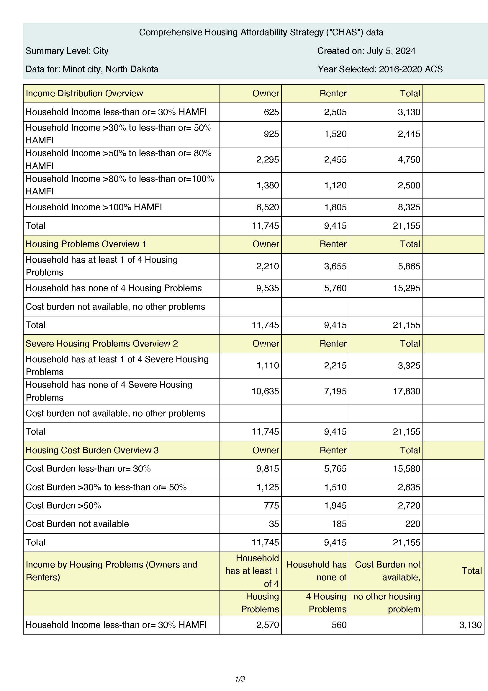
CHAS
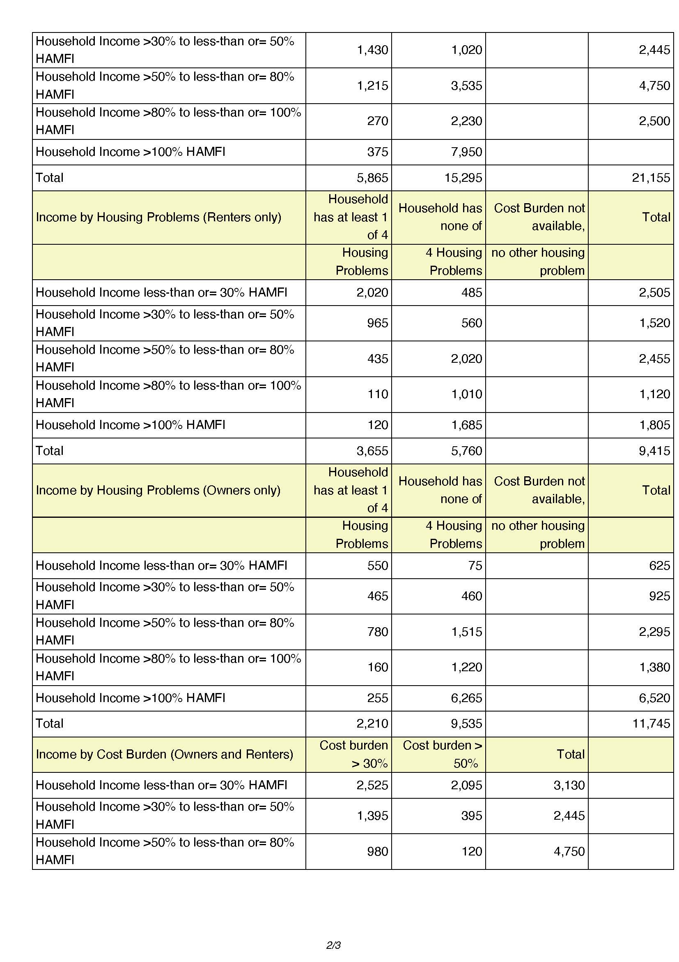
CHAS 2
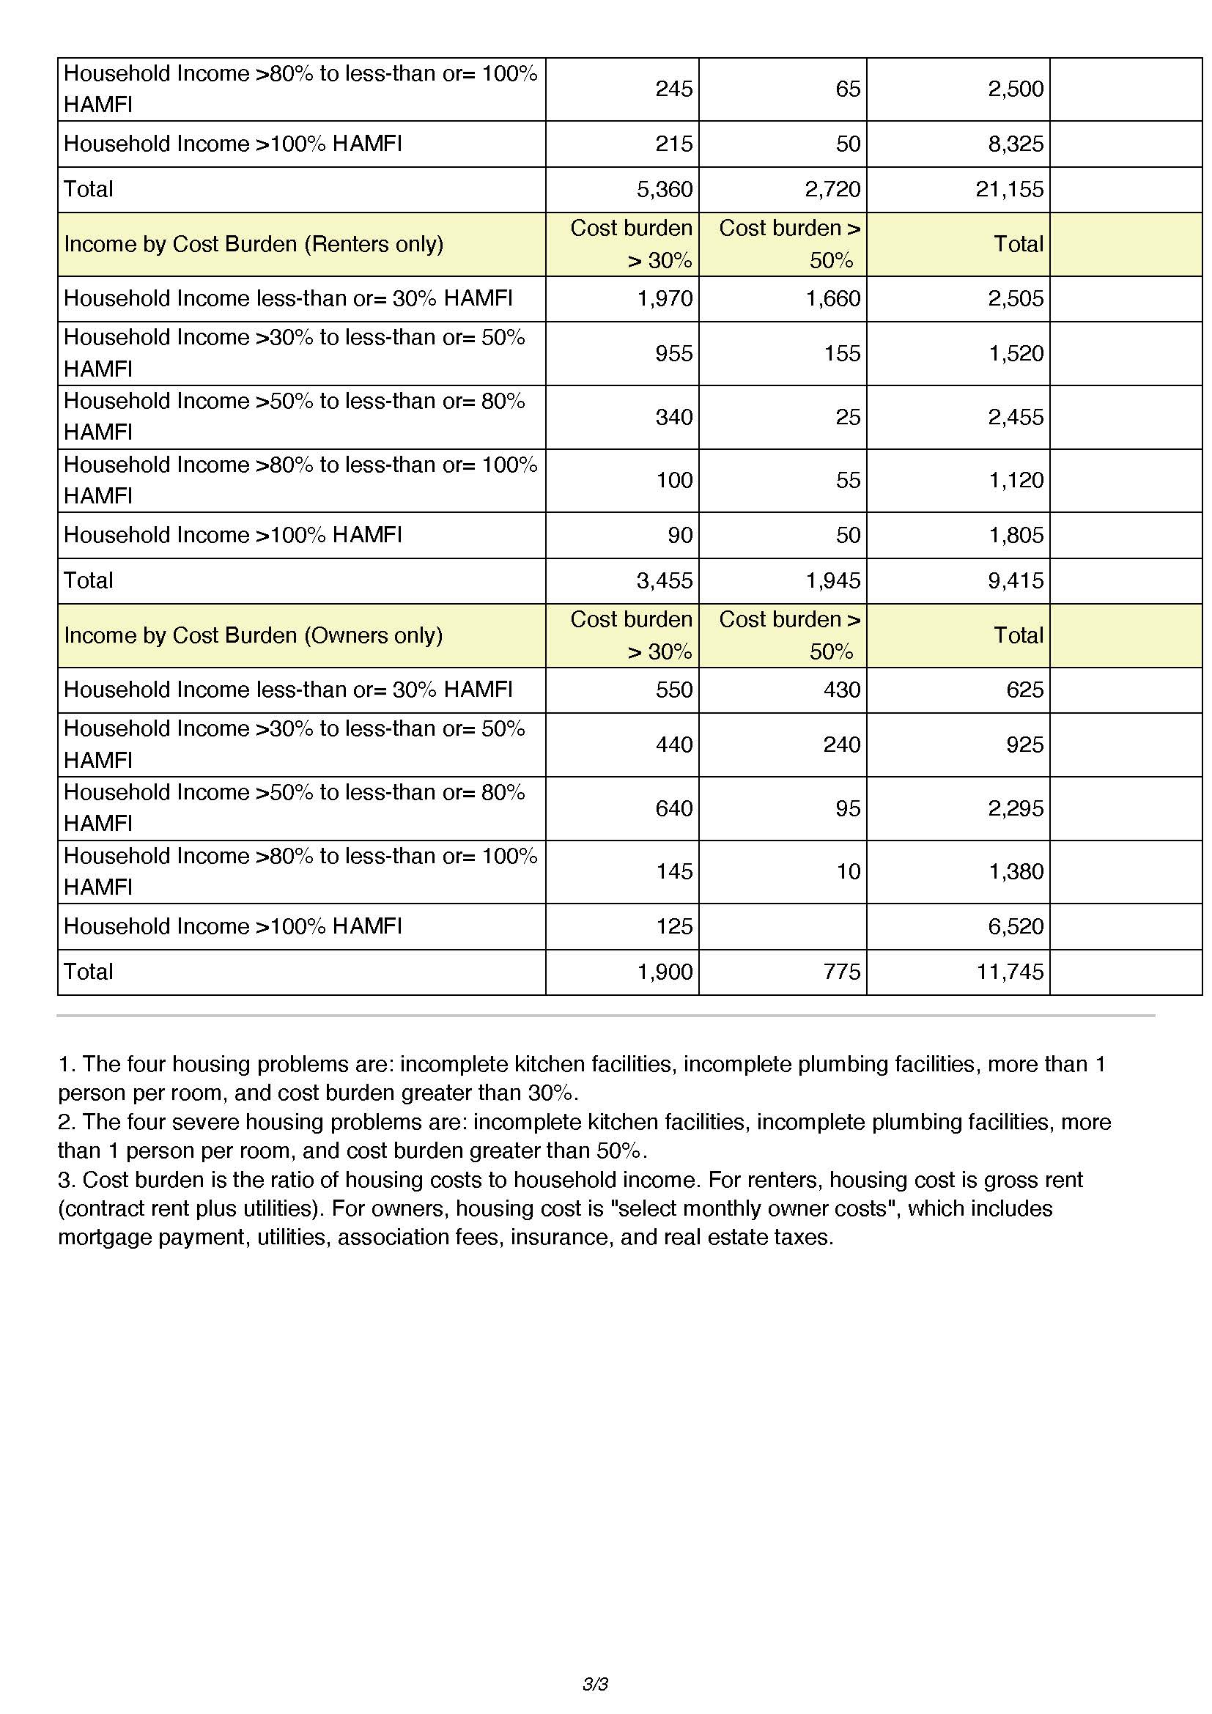
CHAS 3

30%-50% of Area Median Income
Severe Housing Problems* | Has one or more of four housing problems | Has none of the four housing problems | Household has no/negative income, but none of the other housing problems
Jurisdiction as a whole | 485 | 1,960 | 0
White | 420 | 675 | 0
Black / African American | 10 | 155 | 0
Asian | 0 | 25 | 0
American Indian, Alaska Native | 0 | 0 | 0
Pacific Islander | 0 | 0 | 0
Hispanic | 55 | 110 | 0
Other | 0 | 0 | 0
Table 18 – Severe Housing Problems 30 - 50% AMI

Data Source Comments:

*The four severe housing problems are:
1. Lacks complete kitchen facilities, 2. Lacks complete plumbing facilities, 3. More than 1.5 persons per room, 4.Cost Burden over 50%

50%-80% of Area Median Income
Severe Housing Problems* | Has one or more of four housing problems | Has none of the four housing problems | Household has no/negative income, but none of the other housing problems
Jurisdiction as a whole | 385 | 4,365 | 0
White | 295 | 3,590 | 0
Black / African American | 0 | 355 | 0
Asian | 15 | 215 | 0
American Indian, Alaska Native | 50 | 8 | 0
Pacific Islander | 0 | 55 | 0
Hispanic | 24 | 55 | 0
Other | 0 | 0 | 0
Table 19 – Severe Housing Problems 50 - 80% AMI

Data Source Comments:

*The four severe housing problems are:
1. Lacks complete kitchen facilities, 2. Lacks complete plumbing facilities, 3. More than 1.5 persons per room, 4.Cost Burden over 50%

80%-100% of Area Median Income
Severe Housing Problems* | Has one or more of four housing problems | Has none of the four housing problems | Household has no/negative income, but none of the other housing problems
Jurisdiction as a whole | 90 | 2,415 | 0
White | 65 | 1,885 | 0
Black / African American | 10 | 220 | 0
Asian | 0 | 85 | 0
American Indian, Alaska Native | 0 | 15 | 0
Pacific Islander | 30 | 0 | 0
Hispanic | 15 | 115 | 0
Other | 0 | 0 | 0
Table 20 – Severe Housing Problems 80 - 100% AMI

Data Source Comments:

*The four severe housing problems are:
1. Lacks complete kitchen facilities, 2. Lacks complete plumbing facilities, 3. More than 1.5 persons per room, 4.Cost Burden over 50%

Discussion

NA-25 Disproportionately Greater Need: Housing Cost Burdens – 91.205 (b)(2)
Assess the need of any racial or ethnic group that has disproportionately greater need in comparison to the needs of that category of need as a whole.
Introduction:
Cost burden is the fraction of a household's total gross income spent on housing costs. Homeowners' housing costs include mortgage payments, taxes, insurance, and utilities. For renters, housing costs include rent paid by the tenant plus utilities. This section evaluates the housing cost burden from a racial or ethnic group perspective.
A disproportionately greater need exists when the members of a racial or ethnic group at an income level experience housing problems at a greater rate (10% or more) than the income level as a whole.
HUD defines cost-burdened families as those "who pay more than 30 percent of their income for housing" and "may have difficulty affording necessities such as food, clothing, transportation, and medical care." Severe rent burden is defined as paying more than 50 percent of one's income on rent.
The tables display cost burden information for Minot and information for each racial and ethnic group is being researched.
Cost Burden is described in the tables as:
- No cost burden (less than 30%)
- Cost burden (30-50%)
- Severe cost burden (more than 50%)
- No/negative income.
No/negative income households are those whose income is zero or negative due to self-employment, dividends, and net rental income. These households are not included in the other two categories but still require housing assistance and are counted separately.
Housing Cost Burden
Housing Cost Burden | <=30% | 30-50% | >50% | No / negative income (not computed)
Jurisdiction as a whole | 15,575 | 2,640 | 2,720 | 297
White | 13,145 | 2,005 | 2,255 | 155
Black / African American | 850 | 185 | 60 | 4
Asian | 360 | 80 | 0 | 0
American Indian, Alaska Native | 255 | 15 | 55 | 0
Pacific Islander | 55 | 0 | 35 | 0
Hispanic | 550 | 240 | 265 | 65
Table 21 – Greater Need: Housing Cost Burdens AMI

Data Source Comments:

Discussion:

NA-30 Disproportionately Greater Need: Discussion – 91.205(b)(2)
Are there any Income categories in which a racial or ethnic group has disproportionately greater need than the needs of that income category as a whole?

If they have needs not identified above, what are those needs?

Are any of those racial or ethnic groups located in specific areas or neighborhoods in your community?

NA-35 Public Housing – 91.205(b)
Introduction
Totals in Use
Program Type
 | Certificate | Mod-Rehab | Public Housing | Vouchers
 |  |  |  | Total | Project -based | Tenant -based | Special Purpose Voucher
 |  |  |  |  |  |  | Veterans Affairs Supportive Housing | Family Unification Program | Disabled  *
# of units vouchers in use | 0 | 0 | 255 | 582 | 0 | 582 | 0 | 0 | 0

Table 22 - Public Housing by Program Type
*includes Non-Elderly Disabled, Mainstream One-Year, Mainstream Five-year, and Nursing Home Transition

Data Source: | PIC (PIH Information Center)

Characteristics of Residents

Program Type
 | Certificate | Mod-Rehab | Public Housing | Vouchers
 |  |  |  | Total | Project -based | Tenant -based | Special Purpose Voucher
 |  |  |  |  |  |  | Veterans Affairs Supportive Housing | Family Unification Program
Average Annual Income | 0 | 0 | 13,309 | 11,389 | 0 | 11,389 | 0 | 0
Average length of stay | 0 | 0 | 5 | 4 | 0 | 4 | 0 | 0
Average Household size | 0 | 0 | 1 | 2 | 0 | 2 | 0 | 0
# Homeless at admission | 0 | 0 | 0 | 1 | 0 | 1 | 0 | 0
# of Elderly Program Participants (>62) | 0 | 0 | 69 | 69 | 0 | 69 | 0 | 0
# of Disabled Families | 0 | 0 | 129 | 126 | 0 | 126 | 0 | 0
# of Families requesting accessibility features | 0 | 0 | 255 | 582 | 0 | 582 | 0 | 0
# of HIV/AIDS program participants | 0 | 0 | 0 | 0 | 0 | 0 | 0 | 0
# of DV victims | 0 | 0 | 0 | 0 | 0 | 0 | 0 | 0
Table 24 – Characteristics of Public Housing Residents by Program Type

Data Source: | PIC (PIH Information Center)

Race of Residents
Program Type
Race | Certificate | Mod-Rehab | Public Housing | Vouchers
 |  |  |  | Total | Project -based | Tenant -based | Special Purpose Voucher
 |  |  |  |  |  |  | Veterans Affairs Supportive Housing | Family Unification Program | Disabled  *
White | 0 | 0 | 229 | 461 | 0 | 461 | 0 | 0 | 0
Black/African American | 0 | 0 | 8 | 25 | 0 | 25 | 0 | 0 | 0
Asian | 0 | 0 | 0 | 1 | 0 | 1 | 0 | 0 | 0
American Indian/Alaska Native | 0 | 0 | 18 | 95 | 0 | 95 | 0 | 0 | 0
Pacific Islander | 0 | 0 | 0 | 0 | 0 | 0 | 0 | 0 | 0
Other | 0 | 0 | 0 | 0 | 0 | 0 | 0 | 0 | 0

*includes Non-Elderly Disabled, Mainstream One-Year, Mainstream Five-year, and Nursing Home Transition
Table 25 – Race of Public Housing Residents by Program Type
Data Source: | PIC (PIH Information Center)

Ethnicity of Residents
Program Type
Ethnicity | Certificate | Mod-Rehab | Public Housing | Vouchers
 |  |  |  | Total | Project -based | Tenant -based | Special Purpose Voucher
 |  |  |  |  |  |  | Veterans Affairs Supportive Housing | Family Unification Program | Disabled  *
Hispanic | 0 | 0 | 3 | 15 | 0 | 15 | 0 | 0 | 0
Not Hispanic | 0 | 0 | 252 | 567 | 0 | 567 | 0 | 0 | 0

*includes Non-Elderly Disabled, Mainstream One-Year, Mainstream Five-year, and Nursing Home Transition
Table 26 – Ethnicity of Public Housing Residents by Program Type
Data Source: | PIC (PIH Information Center)

Section 504 Needs Assessment: Describe the needs of public housing tenants and applicants on the waiting list for accessible units:
Most immediate needs of residents of Public Housing and Housing Choice voucher holders
How do these needs compare to the housing needs of the population at large
Discussion

NA-40 Homeless Needs Assessment – 91.205(c)
Introduction:

If data is not available for the categories "number of persons becoming and exiting homelessness each year," and "number of days that persons experience homelessness," describe these categories for each homeless population type (including chronically homeless individuals and families, families with children, veterans and their families, and unaccompanied youth):

Nature and Extent of Homelessness: (Optional)
Race: | Sheltered: | Unsheltered (optional)
White | 0 | 0
Black or African American | 0 | 0
Asian | 0 | 0
American Indian or Alaska Native | 0 | 0
Pacific Islander | 0 | 0
Ethnicity: | Sheltered: | Unsheltered (optional)
Hispanic | 0 | 0
Not Hispanic | 0 | 0

Data Source Comments:

Estimate the number and type of families in need of housing assistance for families with children and the families of veterans.
McKinney Vento - Minot School District
Minot School District reported that 109 students in school year 2021-2022 were homeless.
Homelessness can have a tremendous impact on children – their education, health, sense of safety, and overall development. Fortunately, researchers find that children are also highly resilient, and the differences between children who have experienced homelessness and low-income children who have not experienced homelessness typically diminish in the years following a homeless episode.
When compared to low-income and homeless families, children experiencing homelessness have been shown to:
- Have higher levels of emotional and behavioral problems;
- Have increased risk of serious health problems;
- Are more likely to experience separations from their families; and
- Experience more school mobility, repeat a grade, be expelled or drop out of school, and have lower academic performance.
"National Alliance to End Homelessness"
The McKinney-Vento Act, which later became part of the No Child Left Behind Act (NCLB), mandates protections and services for homeless children and youth, including those with disabilities. The 2004 reauthorization of IDEA also includes amendments that reinforce timely assessment, inclusion, and continuity of services for homeless children and youth with disabilities.
McKinney-Vento Definition of Homelessness
Anyone who lacks a fixed, regular, and adequate nighttime residence including:
- Sharing the housing of others due to lack of housing, economic hardship, or similar reason
- Living in motels, hotels, trailer parks, camping grounds, due to lack of adequate alternative accommodations
- Living in emergency or transitional shelters
- Abandoned in hospitals
- Awaiting foster care placement
- Living in a public or private place not designed for humans to live
- Living in cars, parks, abandoned buildings, public train stations, etc.
- A migrant child who qualifies under any of the above
US Department of Education, ED Data Express provides data on school districts' annual reports on homeless enrolled students. Minot School District reported that 109 students in school year 2021-2022 were homeless.
Minority students account for a disproportionate number of McKinney-Vento students in Minot.
Describe the Nature and Extent of Homelessness by Racial and Ethnic Group.

Describe the Nature and Extent of Unsheltered and Sheltered Homelessness.

Discussion:

NA-45 Non-Homeless Special Needs Assessment - 91.205 (b,d)
Introduction:

Describe the characteristics of special needs populations in your community:
What are the housing and supportive service needs of these populations and how are these needs determined?
Discuss the size and characteristics of the population with HIV/AIDS and their families within the Eligible Metropolitan Statistical Area:
If the PJ will establish a preference for a HOME TBRA activity for persons with a specific category of disabilities (e.g., persons with HIV/AIDS or chronic mental illness), describe their unmet need for housing and services needed to narrow the gap in benefits and services received by such persons. (See 24 CFR 92.209(c)(2) (ii))
Discussion:

NA-50 Non-Housing Community Development Needs – 91.215 (f)
Describe the jurisdiction’s need for Public Facilities:
Minot will prioritize improving public facilities to better meet the needs of low- and moderate-income residents and residents with special needs. Public facility improvements that help improve homeless shelters and domestic violence shelters ensure that residents in the greatest need have a safe, warm, and inviting place to reside during a crisis. Improving the built environment to help provide great accessibility and mobility helps ensure that all residents access needed services.
There is currently no year round low-barrier shelter for men, women, and families experiencing homelessness in Minot
How were these needs determined?
The City had a robust approach to determining community needs during the formation of the Consolidated Plan. The City had a community needs assessment survey as part of a recently completed housing study, held two stakeholder listening sessions, held public meetings to help determine needs, and interviewed key stakeholders.

Describe the jurisdiction’s need for Public Improvements:
Public improvements help low- and moderate-income residents have a better quality of life, better access to transportation and neighborhood amenities, and often provide additional safety. The City will prioritize accessibility as it relates to mobility.
How were these needs determined?
The City had a robust approach to determining community needs during the formation of the Consolidated Plan. The City had a community needs assessment survey as part of a recently completed housing study, held two stakeholder listening sessions, held public meetings to help determine needs, and interviewed key stakeholders.

Describe the jurisdiction’s need for Public Services:
Public services are one of the best ways to directly impact and improve the lives of low- and moderate-income (LMI) residents through the support of key services. Minot plans to partner with non-profit organizations in the community that help LMI residents.
How were these needs determined?
The City had a robust approach to determining community needs during the formation of the Consolidated Plan. The City completed a community needs assessment survey as part of a recently completed housing study, held two stakeholder listening sessions, held public meetings to help determine needs, and interviewed key stakeholders.
Potential service providers will continue to be part of the prioritization process.

Housing Market Analysis

MA-05 Overview
Housing Market Analysis Overview:
The purpose of the Market Analysis is to provide a clear picture of the environment in which the jurisdiction must administer its programs over the course of the Consolidated Plan. In conjunction with the Needs Assessment, the Market Analysis will provide the basis for the Strategic Plan and the programs and projects to be administered.
The Housing Market Analysis provides information on:
- Significant characteristics of Minot's housing market in general, including the supply, demand, condition, and cost of housing
- Housing stock available to serve persons with disabilities and other special needs
- Condition and need of public and assisted housing
- A brief inventory of facilities, housing, and services to meet the needs of homeless persons
- Regulatory barriers to affordable housing
- Significant characteristics of the jurisdiction's economy

MA-10 Number of Housing Units – 91.210(a)&(b)(2)
Introduction
The United States needs more housing and more varied types of housing to meet households’ needs throughout the country. Some economists estimate that one consequence of the 2008 foreclosure crisis was the slow rebound in home construction while household growth continued, resulting in the underproduction of housing by more than 3 million units.
Although home production has recently been on the rise, building permits, one indicator of new housing supply, remain below historical averages and far below the level needed to eliminate the deficit in housing.
The consequences of inadequate supply are higher housing costs for both renting and buying a home. More than 37 million renter and owner households spent more than 30 percent of their income for housing in 2019. In the years prior to the pandemic, low-interest rates for mortgage loans and increasing incomes, not lower home values, had reduced owner cost burden. For renters, increasing incomes were matched by rising rents, maintaining cost burdens despite a strong economy.
"Opportunities to Increase Housing Production and Preservation" HUD PD&R, September 7, 2021
Increasing interest rates over the recent years would typically reduce the initial housing purchase cost, but this has not been realized in most housing markets.
The market in Minot has been further affected by the loss of housing to a flooding disaster in 2011. While many homes have been rebuilt, some areas are unsuitable or unavailable for rebuilding. This has primarily decreased the availability of affordable rentals.

All residential properties by number of units
Property Type | Number | %
1-unit detached structure | 11,052 | 47%
1-unit, attached structure | 1,697 | 7%
2-4 units | 2,026 | 9%
5-19 units | 2,531 | 11%
20 or more units | 4,476 | 19%
Mobile Home, boat, RV, van, etc | 1,928 | 8%
Total | 23,710 | 100%
Table 31 – Residential Properties by Unit Number

Data Source Comments: | 2022 Census Data: Table DP04 Selected Housing Characteristics

Unit Size by Tenure
 | Owners |  | Renters
 | Number | % | Number | %
No bedroom | 118 | 1% | 320 | 3%
1 bedroom | 273 | 2% | 2,042 | 22%
2 bedrooms | 2,384 | 20% | 4,507 | 49%
3 or more bedrooms | 9,204 | 77% | 2,313 | 25%
Total | 11,979 | 100% | 9,182 | 99%
Table 32 – Unit Size by Tenure

Data Source Comments: | 2022 Census Data: Table B25042 Tenure by Bedrooms

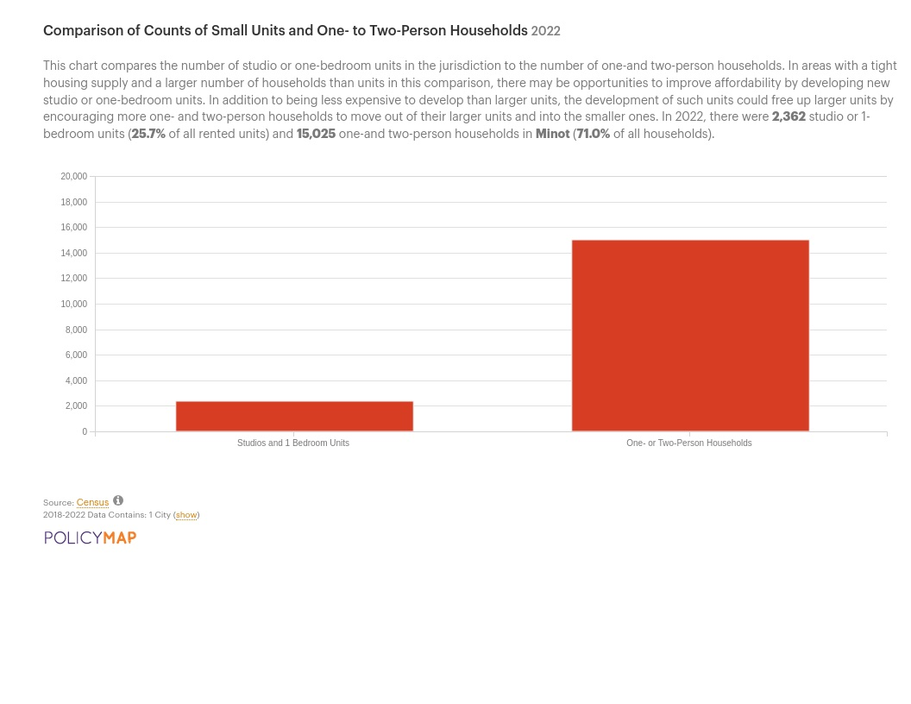
Comparisone of units vs small households
Describe the number and targeting (income level/type of family served) of units assisted with federal, state, and local programs.
There are two main types of affordable housing: (a) dedicated affordable housing that comes with binding rent and/or income restrictions to ensure it is occupied by low-income households, and (b) market affordable housing – units that rent or sell at an affordable price but have no binding restrictions. This section focuses on the first type, providing information about the amount and location of dedicated affordable housing in the jurisdiction. Surveying the landscape of existing affordable housing in the jurisdiction can help clarify gaps left by federal subsidies and identify the extent to which existing dedicated affordable housing units may be at risk of loss from the subsidized inventory as federal regulatory agreements expire.
In 2021, the inventory of federally subsidized rental housing in Minot included 814 units and comprised 8.9% of Minot’s total rental stock. Of these subsidized units, 248 are HUD public housing units. The remaining units are privately owned and receive federal subsidies. In addition to the federally subsidized rental programs tracked here, some jurisdictions also have rental units that are subsidized by state or local sources. Not included in this inventory are approximately 285 Housing Choice Vouchers, the majority of which are tenant-based (assigned to individuals who may use them in rentalhousing of their choosing) and a portion of which may be project-based (tied to specific units). Tenant-based vouchers may be used in Low IncomeHousing Tax Credit properties or in other privately-owned units that meet voucher program criteria.

Provide an assessment of units expected to be lost from the affordable housing inventory for any reason, such as expiration of Section 8 contracts.
By 2025, the affordability restrictions on 104 units of federally subsidized housing in Minot are set to expire. Restrictions on an additional 146 units are set to expire by 2030. Some of these units will remain within the subsidized inventory as owners elect to renew their rent subsidy contracts or recapitalize the properties using new federal subsidies. In other cases, the units may remain affordable even after the restrictions expire due to a soft rental market, though Minot is experiencing historically low vacancy rates. In still other cases, however, the lifting of the affordability restrictions will allow for rents to rise substantially, reducing the stock of units renting at an affordable level
Does the availability of housing units meet the needs of the population?
The need for smaller units is strong within the City of Minot.
Households that are cost-burdened may be able to find smaller, less expensive housing if unit size more accurately matched household size.
Describe the need for specific types of housing:

Discussion
The neighborhood poverty rates provided for each federally subsidized housing program (Housing Choice Vouchers, Public Housing, Low-Income Housing Tax Credit properties, and HUD Multifamily properties) represent the average for all neighborhoods where each type of assisted housing is located. High average neighborhood poverty rates for federally subsidized housing can indicate that units are unevenly distributed within a jurisdiction, or concentrated in neighborhoods with limited educational and economic mobility opportunities.
In Minot, the average neighborhood poverty rate was highest for households living in HUD Multifamily units. HUD Multifamily units were, on average, located in neighborhoods where 17.1% of the population had incomes below the federal poverty line. The average neighborhood poverty rate was lowest for households living in HUD Housing Choice Voucher units. HUD Housing Choice Voucher units were, on average, located in neighborhoods where 9.4% of the population had incomes below the poverty line.

MA-15 Housing Market Analysis: Cost of Housing - 91.210(a)
Introduction

Cost of Housing
 | Base Year: 2017 | Most Recent Year: 2022 | % Change
Median Home Value | 0 | 0 | 0%
Median Contract Rent | 0 | 0 | 0%
Table 33 – Cost of Housing

Data Source Comments: | 2022 Census Data: Table DP04 Selected Housing Characteristics

Rent Paid | Number | %
Less than $500 | 881 | 0.0%
$500-999 | 4,099 | 0.0%
$1,000-1,499 | 3,010 | 0.0%
$1,500-1,999 | 515 | 0.0%
$2,000 or more | 424 | 0.0%
Total | 8,929 | 0.0%
Table 34 - Rent Paid

Data Source Comments: | 2022 Census Data: Table DP04 Selected Housing Characteristics

Housing Affordability
Number of Units affordable to Households earning | Renter | Owner
30% HAMFI | 2,505 | No Data
50% HAMFI | 1,520 | 1,550
80% HAMFI | 2,455 | 2,295
100% HAMFI | No Data | 1,380
Total | 6,480 | 5,225
Table 35 – Housing Affordability

Data Source Comments: | 2016-2020 CHAS ACSSome fields have no data allowed. Owner 50% includes 625 that should be included in the 30% data box. 100% HAMFI Renters = 1120, not reflected elsewhere on the table.

Monthly Rent
Monthly Rent ($) | Efficiency (no bedroom) | 1 Bedroom | 2 Bedroom | 3 Bedroom | 4 Bedroom
Fair Market Rent | 681 | 744 | 978 | 1,378 | 1,660
High HOME Rent | 681 | 744 | 978 | 1,368 | 1,526
Low HOME Rent | 681 | 744 | 978 | 1,378 | 1,660
Table 36 – Monthly Rent

Data Source Comments: | HUD Exchange 2024 HOME rents for Ward County, ND

Is there sufficient housing for households at all income levels?
Data for monthly rent for fair market, high HOME, and low HOME rent is from the US Department of Housing and Urban Development. The lack of affordable housing impacts low- and moderate-income residents the greatest. The steadily increasing rent costs compound the financial struggles that these families are at risk of experiencing. Additionally, the growing need for new rental housing units and aging rental housing unit stock results in many renters living in substandard housing conditions.
AFFORDABLE, BUT NOT AVAILABLE
Homes that are affordable to extremely low-income renters are not necessarily available to them. In the private market, households can occupy homes that cost less than 30% of their incomes, and many do. When higher-income households occupy rental homes also affordable to lower-income households, they render those homes unavailable to the lower-income households. Extremely low-income renters must compete with all higher-income households for the limited number of rental homes affordable to them in the private market. To truly measure the housing options extremely low-income renters have, we must account for the fact that higher-income renters occupy some of the most affordable units. Rental homes are both affordable and available for households of a specific income group if the homes are affordable to them and they are not occupied by higher-income households.
EXTREMELY LOW-INCOME RENTERS
The vast majority of extremely low-income renters work in low-wage jobs or are unable to work. With wages insufficient to pay for modest rental housing even when individuals work full-time year-round, a brief furlough or loss of hours, as we have seen over the past year, can create debts that renters can never repay. Extremely low-income renters in the labor force, many already struggling to pay their rents before the pandemic, were significantly impacted by COVID-19. Low-wage work comprised a disproportionate share of industries most affected by COVID-19 shutdowns. Extremely low-income renters were likely impacted by the closures of restaurants, hotels, and other places of low-wage employment.
The Gap, A Shortage of Affordable Homes, National Low Income Housing Coalition, March 2021
How is affordability of housing likely to change considering changes to home values and/or rents?
As the economy improves, rental prices continue to increase. The trend over the past decade has been a higher rental increase than the increase in monthly wages. As this trend continues, it puts more significant financial pressure on low- and moderate-income families who are spending an ever-increasing percentage of their income on housing costs.
As higher-income renters and distressed homeowners seek cheaper alternatives to their current housing, competition for less expensive rental homes may actually increase. Meanwhile, few of the lowest-income renters have the option of leaving the rental market altogether. Consequently, rents for the least expensive homes may be less responsive to economic downturns, and in some cases, they could even increase because of greater demand. Even if rents at the bottom-end of the market fall during a downturn, they will not fall sufficiently to provide extremely low-income renters with an adequate supply of affordable housing. Owners have an incentive to abandon their rental properties or convert them to other uses when rental income is too low to cover basic operating costs and maintenance. They have little incentive to provide housing in the private market at rents that are affordable to extremely low-income renters. During periods of economic growth, the private market on its own still does not provide an adequate supply of rental housing affordable to low-income households. The rents that the lowest-income households can afford to pay typically do not cover the development costs and operating expenses of new housing. While new construction for higher-income renters encourages a chain of household moves that eventually benefits lower-income renters, new luxury units may not impact rents at the bottom of the market as much as they do rents at the top.
The Gap, A Shortage of Affordable Homes, National Low Income Housing Coalition, March 2021
How do HOME rents / Fair Market Rent compare to Area Median Rent? How might this impact your strategy to produce or preserve affordable housing?
Since 1974 the U.S. Department of Housing and Urban Development (HUD) has helped low-income households obtain better rental housing and reduce the share of their income that goes toward rent through a program that relies on the private rental market. A key parameter in operating the certificate
and voucher programs is the Fair Market Rent (FMR). FMRs play different roles in the certificate and voucher programs. In both programs, FMRs set limits. In the certificate program, FMRs set limits on what units can be rented; in the voucher program, FMRs set limits on the subsidy provided to the household. Certificate program households cannot rent units with gross rents exceeding the FMR; the recipients receive a subsidy equal to the difference between the gross rent and 30 percent of their incomes. Voucher program households receive a subsidy equal to the difference between the FMR and 30 percent of their monthly incomes. Participants in the voucher program can choose units to live in with gross rents higher than the FMR, but they must pay the full cost of the difference between the gross rent and the FMR, plus 30 percent of their income.
FMRs function primarily to control costs. Research has shown that program recipients act rationally and choose units with gross rents close to the FMRs, that is, the best units available under program
rules. While budget realities and sensitivities to public acceptance exert pressures to set FMRs at low levels, other concerns create countervailing incentives to raise FMRs. For the Section 8 program to work properly, certificate and voucher holders must have an adequate supply of decent, safe, and sanitary rental units to choose from. Higher quality units command higher rents, so FMRs must be sufficiently high to provide acceptable choices for participants. In addition, the certificate and voucher programs were designed to allow assisted households to choose among different neighborhoods. The FMRs must also be high enough to provide acceptable choices among neighborhoods.
Fair Market Rent (FMR) and the HOME High and Low rental limits begin to diverge in Minot in the three- to four-bedroom units. These units are in high demand for families renting homes and are often priced above what a housing choice voucher holder can afford.
Discussion
A variety of housing developments have the potential to help shift the community toward having a greater variety of affordable housing options.
The Minot Housing Authority is working to rehab a large building and provide additional rental opportunities. There are additional proposed developments that may come to fruition over the next five years. The city stands ready to assist whenever possible.
Many Minot households experience housing cost burdens, paying more than 30% of their income on housing-related costs. Cost-burdened households have significantly increased since 2016 as incomes have not kept pace with housing costs. The most significant portion of cost-burdened households are renters, which aligns with national trends. Severely cost-burdened renters are a much larger portion of the housing market as compared to homeowners.

MA-20 Housing Market Analysis: Condition of Housing – 91.210(a)
Introduction
Housing is a major element of people's material living standards. It is essential to meet basic needs, such as for shelter from weather conditions and to offer a sense of personal security, privacy, and personal space. Good housing conditions are also essential for people's health and affect childhood development.
Housing is the key to reducing intergenerational poverty and increasing economic mobility. Research shows that increasing access to affordable housing is the most cost-effective strategy for reducing childhood poverty and increasing economic mobility in the United States. Stanford economist Raj Chetty found that children who moved to lower-poverty neighborhoods saw their earnings as adults increase by approximately 31%, an increased likelihood of living in better neighborhoods as adults, and a lowered likelihood of becoming a single parent. Moreover, children living in stable, affordable homes are more likely to thrive in school and have greater opportunities to learn inside and outside the classroom.
Increasing access to affordable housing bolsters economic growth. Research shows that the shortage of affordable housing costs the American economy about $2 trillion a year in lower wages and productivity. Without affordable housing, families have constrained opportunities to increase earnings, causing slower GDP growth. In fact, researchers estimate that the growth in GDP between 1964 and 2009 would have been 13.5% higher if families had better access to affordable housing. This would have led to a $1.7 trillion increase in income or $8,775 in additional wages per worker. Moreover, each dollar invested in affordable housing boosts local economies by leveraging public and private resources to generate income—including resident earnings and additional local tax revenue—and supports job creation and retention.
"The Problem," National Low Income Housing Alliance
Housing Rehabilitation
When low- to moderate-income families have unaffordable homes, the maintenance and upkeep of those housing units often are delayed or not addressed because of financial constraints. Housing rehabilitation is critical to ensure residents have a safe, healthy, and livable home environment. Delipidated housing can have an immediate impact on a family's health. Lack of air conditioning in the hot summer months has been linked to a sharp increase in cardiovascular events. Mold, mildew, and other water leak issues often lead to asthma, headaches, and other serious conditions.
Describe the jurisdiction's definition of "standard condition" and "substandard condition but suitable for rehabilitation":
For this Consolidated Plan, Minot will use the HUD housing quality standards as defined below:
1. Standard Condition. A unit of housing is considered to be in standard condition if it is generally in good repair, with no substandard habitability elements (i.e., lacking complete plumbing or kitchen facilities) or exterior elements. Such units may be eligible for housing rehabilitation funding if interior conditions are such that the HUD Section 8 Housing Quality Standards are not met, or a threat to the integrity or livability of the unit exists and should be addressed. Examples of ways in which the interiors of such homes might be rehabilitated include the replacement of heating systems, electrical system repairs or upgrades, plumbing system repairs or upgrades, energy efficiency improvements, and accessibility improvements.
2. Substandard Condition but Suitable for Rehabilitation. This category describes dwelling units that do not meet one or more of the HUD Section 8 quality standard conditions, likely due to deferred maintenance or work without permits, but that are both financially and structurally feasible for rehabilitation. Such units may be lacking complete plumbing and kitchen facilities and/or may have exterior elements in need of repair (e.g., a roof in need of replacement, siding in need of repair or replacement, missing or failing foundation). In order to be suitable for rehabilitation, the unit value generally exceeds the cost of repairs or upgrades that would be required to bring it to standard condition. This category of property does not include units needing correction, minor livability problems, or maintenance work.
3. Substandard Condition and Not Suitable for Rehabilitation. This category describes dwelling units in such poor conditions as to be neither structurally nor financially feasible for rehabilitation. Such units will typically have an improvement value that is less than the cost of addressing the habitability and exterior elements that cause its classification as "substandard" or will be considered unfit to occupy for safety reasons by the city's building official.
Note: The City does not have a complete inventory of vacant dwellings. The HUD prepopulated fields for "vacant units" and "REO Properties" are blank because data is unavailable for the jurisdiction.
Note: The Condition of Units table did not auto populate. Information could not be reliably obtained. See NA sections for similar information.
Condition of Units
Condition of Units | Owner-Occupied |  | Renter-Occupied
Condition of Units | Number | % | Number | %
With one selected Condition | 0 | 0% | 0 | 0%
With two selected Conditions | 0 | 0% | 0 | 0%
With three selected Conditions | 0 | 0% | 0 | 0%
With four selected Conditions | 0 | 0% | 0 | 0%
No selected Conditions | 0 | 0% | 0 | 0%
Total | 0 | 0% | 0 | 0%
Table 37 - Condition of Units
Data Source: | 2016-2020 ACS

Year Unit Built
Year Unit Built | Owner-Occupied |  | Renter-Occupied
Year Unit Built | Number | % | Number | %
2000 or later | 3,203 | 27% | 4,737 | 52%
1980-1999 | 1,899 | 16% | 1,666 | 18%
1950-1979 | 5,247 | 44% | 1,704 | 19%
Before 1950 | 1,630 | 14% | 1,075 | 12%
Total | 11,979 | 101% | 9,182 | 101%
Table 38 – Year Unit Built

Alternate Data Source Name:
2022 Census Data (1)

Data Source Comments: | 2022 Census Data: Table B25036 Tenure by Year Structure Built

Risk of Lead-Based Paint Hazard
Risk of Lead-Based Paint Hazard | Owner-Occupied |  | Renter-Occupied
Risk of Lead-Based Paint Hazard | Number | % | Number | %
Total Number of Units Built Before 1980 | 0 | 0% | 0 | 0%

Housing Units build before 1980 with children present | 0 | 0% | 0 | 0%
Table 39 – Risk of Lead-Based Paint
Data Source: | 2016-2020 ACS (Total Units) 2016-2020 CHAS (Units with Children present)

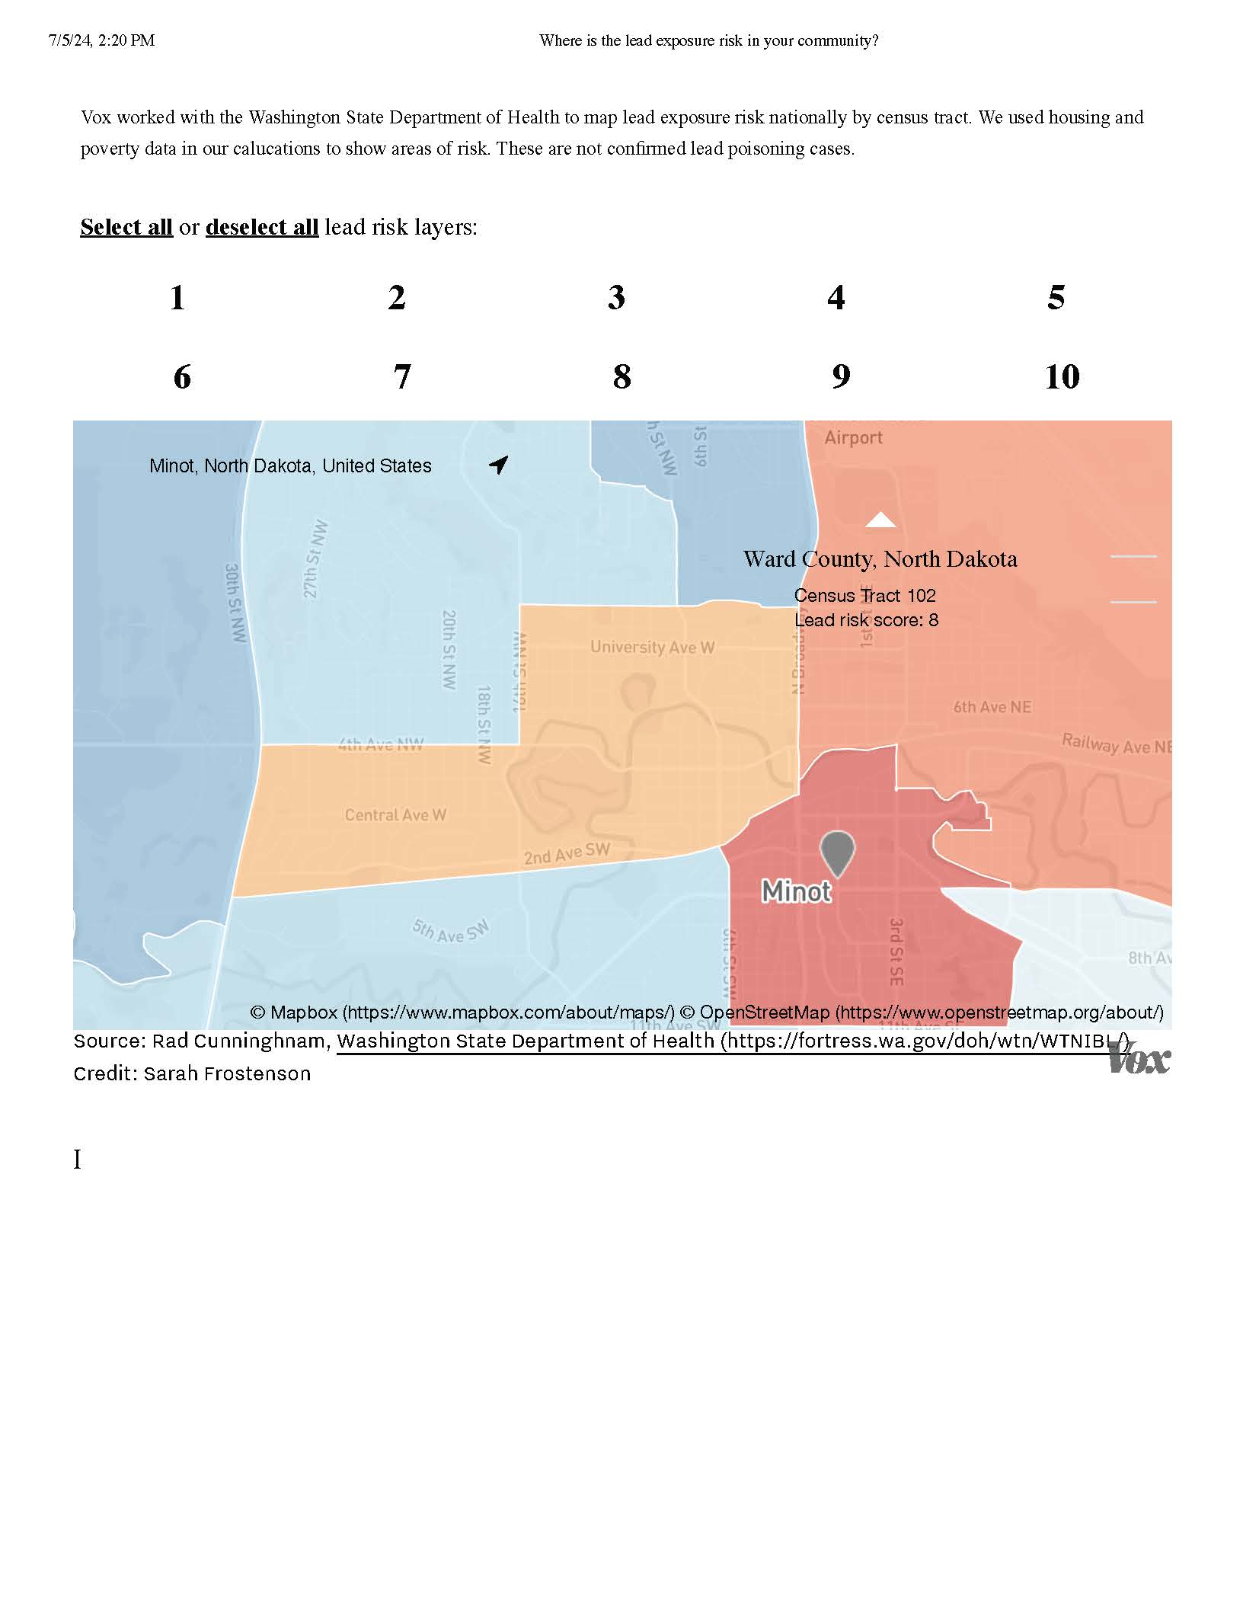
Lead Risk

Vacant Units
 | Suitable for Rehabilitation | Not Suitable for Rehabilitation | Total
Vacant Units | 0 | 0 | 0
Abandoned Vacant Units | 0 | 0 | 0
REO Properties | 0 | 0 | 0
Abandoned REO Properties | 0 | 0 | 0
Table 40 - Vacant Units
Data Source: | 2005-2009 CHAS

Need for Owner and Rental Rehabilitation
<TYPE=[text] REPORT_GUID=[F8DC4D3147433947165558A235C46686] PLAN_SECTION_ID=[1313801000]>
Estimated Number of Housing Units Occupied by Low or Moderate Income Families with LBP Hazards
Environmental lead is a toxic substance affecting the growth and development of up to one million U.S. preschool children today, with effects ranging from learning disabilities to death. High lead levels can cause many health problems by damaging the brain, nervous system, and kidneys. Lead poisoning can cause decreased intelligence, behavioral and speech problems, anemia, decreased muscle and bone growth, poor muscle coordination, and hearing damage. Lead exposures remain prevalent despite considerable knowledge and increased screening and intervention efforts.
Increased lead exposure and increased body burden of lead remain a significant problem for children in the United States. Lead is an environmental toxicant that may cause adverse health effects to the nervous, hematopoietic, endocrine, renal, and reproductive systems. Lead exposure in young children is particularly hazardous because children absorb lead more readily than adults. Many children exposed to lead do not exhibit any signs of the disease. The child's signs or symptoms could be mistaken for other illnesses and go undiagnosed. Children's developing nervous system is particularly susceptible to the effects of lead. The underdeveloped blood-brain barrier in young children increases the risk of lead entering the developing nervous system resulting in neurobehavioral disorders. Blood lead levels (BLLs) at any detectable level have been shown to cause behavioral and developmental disorders; therefore, no safe blood lead level in children has been identified. It is increasingly crucial for continued childhood lead poisoning prevention education and awareness.
Dust from deteriorating lead-based paint is considered the most significant contributor to the lead problem. Lead-contaminated water, soil, and paint are potential sources of children's lead exposure. Until the 1950s, many homes were covered inside and out with leaded paints. Lead began to fall from favor in the 1950s but was still commonly used until it was banned in homes after 1977.
Because of the long-term use of lead-based paints, many homes in the United States contain paint surfaces that are now peeling, chalking, flaking, or wearing away. The dust or paint chips contain high levels of lead that easily find ways into the mouths of young children. A particular problem has emerged due to many homes with lead-based paints, which are now undergoing renovations. Often the dust created by this work has high lead levels, which are readily absorbed by the children's developing bodies.
Discussion
The Washington State Department of Health (WSDOH) developed an index for lead exposure risk that considers the age of housing and poverty as primary risk factors. Vox Media worked with WSDOH to apply the lead exposure risk index nationally.
Minot has a significant amount of housing built before 1980 that may contain lead-based hazards.
- 6,877 owner-occupied, or 57% of all owner-occupied housing
- 2,779 rental units, or 30% of all rental housing
- 2,705 housing units (rental and owner-occupied) were built prior to 1950 and are at high risk for lead-based paint hazards.

MA-25 Public and Assisted Housing – 91.210(b)
Introduction
The Minot Housing Authority provides housing and voucher assistance to low-income Minot residents.
Totals Number of Units
Program Type
 | Certificate | Mod-Rehab | Public Housing | Vouchers
 |  |  |  | Total | Project -based | Tenant -based | Special Purpose Voucher
 |  |  |  |  |  |  | Veterans Affairs Supportive Housing | Family Unification Program | Disabled  *
# of units vouchers available |  |  | 261 | 792 |  |  | 0 | 0 | 0
# of accessible units

*includes Non-Elderly Disabled, Mainstream One-Year, Mainstream Five-year, and Nursing Home Transition
Table 41 – Total Number of Units by Program Type
Data Source: | PIC (PIH Information Center)

Describe the supply of public housing developments:
Describe the number and physical condition of public housing units in the jurisdiction, including those that are participating in an approved Public Housing Agency Plan:
HUD's Real Estate Assessment Center conducts physical property inspections of properties owned, insured, or subsidized by HUD, including public housing and multifamily assisted housing. About 20,000 such inspections are conducted each year to ensure that assisted families have housing that is decent, safe, sanitary, and in good repair. The City used HUD data from www.huduser.org/portal/datasets/pis.html to identify the public housing developments and average inspection scores. Scores range from 0 to 100 and are deficit-based. Scores are reduced based on each deficiency found.
Inspection details enable researchers, advocacy groups, and the general public to
- better understand the physical condition of the HUD-assisted housing stock, as well as changes in the stock over time;
- hold providers accountable for housing quality; and
- plan for future affordable housing needs.
The inspection scores listed below reflect all the public housing and multifamily units listed in the HUD Multifamily Inspection Score and Public Housing Inspection data.

Public Housing Condition
Public Housing Development | Average Inspection Score
Public Housing - Milton R Young Towers | 94
Multifamily -Henry Towers | 50
Table 42 - Public Housing Condition

Describe the restoration and revitalization needs of public housing units in the jurisdiction:
The housing authority is in the process of revitalizing properties under their control.
Describe the public housing agency's strategy for improving the living environment of low- and moderate-income families residing in public housing:
Minot Housing Authority will conduct ongoing analysis to determine the scope of need for additional low income housing opportunities in Ward County and North Central Region, North Dakota. If such needs exist we will endeavor to develop additional housing opportunities by:
- Administering the Housing Choice Voucher Program to its fullest potential, maximizing the number of people served.
- Filling voids not served by private enterprise.
- Building or acquiring units to meet the housing needs of low income persons in our community.
Discussion:

MA-30 Homeless Facilities and Services – 91.210(c)
Introduction
The Minot region has seen growth and population contraction as natural disasters and industry have affected both the inflow and outflow of population over the last decades.
This environment has created great opportunities for some as well as great hardship for others. Affordable housing has become increasingly challenging to secure as rent rates continue to rise and rental vacancy rates reach historic lows. Additionally, the COVID-19 pandemic triggered job loss and reduced wages, further adding to the housing instability of thousands of households throughout North Dakota. Ultimately, homelessness is often the end result and does not happen by choice.
Homelessness stems from a variety of factors;
- Unemployment,
- Unforeseen life changes,
- Substance use,
- Medical emergencies,
- Domestic violence, or
- Mental health issues.
Often, it strikes the people you least expect. Housing instability is particularly challenging due to the limiting wage opportunity and other financial barriers caused by the pandemic. Nonprofits, community organizations, and response networks throughout North Dakota continue to increase capacity, become more sophisticated, and collaborate in their efforts to provide housing and critical support services for the most disadvantaged among us.
Often it is easy to see homelessness simply as someone living on the street. While this is the reality for some, it is not for the majority of those experiencing homelessness.
The list below outlines the various degrees of homelessness.
Imminent Risk of Homelessness: A person or family who will lose their primary nighttime residence within 14 days.
Precariously Housed: A person or family who lack a fixed, regular nighttime residence but have been offered accommodation from friends or family for an indeterminate time.
Fleeing/Attempting to Flee Domestic Violence: A person or family that is fleeing or is attempting to flee domestic violence, has no other residence, lacks resources or support networks, or does not have permanent housing.
Literally Homeless: A person or a family who lacks a fixed, regular and adequate nighttime residence. This typically means living in a place not meant for habitation or an emergency shelter.
Chronically Homeless: A person or family who has experienced homelessness for at least one year—or repeatedly—while having a disabling condition.
Facilities and Housing Targeted to Homeless Households
 | Emergency Shelter Beds |  | Transitional Housing Beds | Permanent Supportive Housing Beds
 | Year Round Beds (Current & New) | Voucher / Seasonal / Overflow Beds | Current & New | Current & New | Under Development
Households with Adult(s) and Child(ren) | 0 | 0 | 0 | 0 | 0
Households with Only Adults | 0 | 0 | 0 | 0 | 0
Chronically Homeless Households | 0 | 0 | 0 | 0 | 0
Veterans | 0 | 0 | 0 | 0 | 0
Unaccompanied Youth | 0 | 0 | 0 | 0 | 0
Table 43 - Facilities and Housing Targeted to Homeless Households

Data Source Comments:

Describe mainstream services, such as health, mental health, and employment services to the extent those services are use to complement services targeted to homeless persons

List and describe services and facilities that meet the needs of homeless persons, particularly chronically homeless individuals and families, families with children, veterans and their families, and unaccompanied youth. If the services and facilities are listed on screen SP-40 Institutional Delivery Structure or screen MA-35 Special Needs Facilities and Services, describe how these facilities and services specifically address the needs of these populations.

MA-35 Special Needs Facilities and Services – 91.210(d)
Introduction
Housing affordablity and access to housing are the greatest challenges to residents who are vulnerable. There are a variety of programs designed to meet the need of residents.

Including the elderly, frail elderly, persons with disabilities (mental, physical, developmental), persons with alcohol or other drug addictions, persons with HIV/AIDS and their families, public housing residents and any other categories the jurisdiction may specify, and describe their supportive housing needs
Substance Abuse and Mental Health Services Administration (SAMHSA): People with mental and substance use disorders are over-represented in the justice system.
They estimate that 18% of the general population suffers from mental illness, while 44% of the jail population and 37% of those in prison suffer from mental and behavioral health conditions.
SAMHSA studies show that 11% of 18-25 year olds and 6% of those over 25 have a substance abuse disorder. 63% of the jail population and 58% of prisoners exhibit substance abuse disorder symptoms.
Upon release from incarceration, people with behavioral and substance abuse-related health issues face many barriers to successful reentry into the community, such as lack of health care, job skills, education, stable housing, and poor connection with community behavioral health providers.
The F5 Project is working to assist those struggling with reentry. From F5 -What began in 2016 as a way of improving the lives of formerly incarcerated individuals in Fargo, ND, the non-profit has evolved into a statewide initiative to bridge resources and provide full-spectrum services to people struggling with incarceration, mental health, and addiction. We are passionate about the human struggle, the endeavor to recreate stories, and know the power of empathy and grace to refresh lives.
The Minot Homeless Coalition helps to provide resource information to residents experiencing homelessness or in danger of becoming homeless. A year-round low-barrier shelter for families, women, and men was ranked the highest need for stakeholders in Minot.
Behavioral and mental health support, including substance abuse services, for LMI residents was a significant concern for stakeholders. Those without insurance struggle with long wait times and lack of service availability. The need for these services was ranked #2 by stakeholders.
Accessibility in rental units is a concern for disabled and elderly residents. Minot has a larger than average disabled and senior population.
Minot Housing Authority offers over 80 units of subsidized senior and disabled housing at Henry Towers. Milton Young Towers is a 14-story subsidized high-rise apartment in historic downtown Minot. In 2022 and 2023, the building saw extensive renovations to every unit and community room, including the creation of many additional two-bedroom units throughout the building. Initially built in 1972, Milton Young Towers is within walking distance of churches, schools, medical facilities, and shopping. The Minot Housing Authority operates additional general and age-restricted properties in the Minot area.
The Community Action Partnership maintains a broad resource list covering assistance, including rent, utility, medication, health (including behavioral health), DV referrals, temporary shelter services, and more.
Domestic Violence Crisis Center -
Founded in 1977, Domestic Violence Crisis Center (DVCC) is a domestic violence and rape crisis center located in Minot, ND. The service region includes Pierce, McHenry, Renville and Ward counties, which comprise approximately 5,793 square miles, with a population of 73,897.
DVCC works with survivors from the initial crisis and beyond by providing options and offering support and resources when needed. Services are free for survivors.
DVCC offers emergency shelter, transitional housing, referral services, crisis intervention, free therapy/counseling, support groups, legal advocacy, and public information/education.

Describe programs for ensuring that persons returning from mental and physical health institutions receive appropriate supportive housing
<TYPE=[text] REPORT_GUID=[F8DC4D3147433947165558A235C46686] PLAN_SECTION_ID=[1350402000]>
Specify the activities that the jurisdiction plans to undertake during the next year to address the housing and supportive services needs identified in accordance with 91.215(e) with respect to persons who are not homeless but have other special needs. Link to one-year goals. 91.315(e)
The City of Minot will help to support the needs of persons who have special needs by implementing the Consolidated Plan goals.
Goal: Public Facilities and Public Infrastructure
Public Facilities and Improvements are publicly-owned facilities and infrastructure such as streets, playgrounds, underground utilities, and buildings owned by non-profits open to the general public. Safe and accessible infrastructure is essential to the quality of life and building communities that support community diversity and stability. In general, public facilities and public improvements are interpreted to include all facilities and improvements that are publicly owned or owned by a nonprofit and open to the general public.
Public Infrastructure Improvements will focus on safe and accessible infrastructure essential to the quality of life and building communities that support community diversity and stability. Public infrastructure improvements will generally include acquiring, constructing, reconstructing, and installing public infrastructure.
Goal: Public Services
Public Service activities provide for a wide range of activities that address needs in the community provided for the target population. Public services can strengthen communities by addressing the needs of specific populations. Public services are an integral part of a comprehensive community development strategy. They can address a range of individual needs and increase CDBG dollars' impact by complementing other activities.
Goal: Housing
Minot is committed to improving and expanding access to safe and affordable housing for low—and moderate-income (LMI) residents. Affordable and safe housing helps to provide financial stability, reduce the chances of a person becoming homeless, and promote housing sustainability.
For entitlement/consortia grantees: Specify the activities that the jurisdiction plans to undertake during the next year to address the housing and supportive services needs identified in accordance with 91.215(e) with respect to persons who are not homeless but have other special needs. Link to one-year goals. (91.220(2))
Many of the activities to be undertaken by the City of Minot will directly benefit the non-homeless special needs population. Special needs populations will also utilize public services.

MA-40 Barriers to Affordable Housing – 91.210(e)
Negative Effects of Public Policies on Affordable Housing and Residential Investment

MA-45 Non-Housing Community Development Assets – 91.215 (f)
Introduction

Economic Development Market Analysis
Business Activity
Business by Sector | Number of Workers | Number of Jobs | Share of Workers  % | Share of Jobs  % | Jobs less workers  %
Agriculture, Mining, Oil & Gas Extraction | 1,648 | 0 | 7 | 0 | -7
Arts, Entertainment, Accommodations | 1,947 | 0 | 8 | 0 | -8
Construction | 1,735 | 0 | 7 | 0 | -7
Education and Health Care Services | 6,664 | 0 | 26 | 0 | -26
Finance, Insurance, and Real Estate | 1,168 | 0 | 5 | 0 | -5
Information | 324 | 0 | 1 | 0 | -1
Manufacturing | 1,359 | 0 | 5 | 0 | -5
Other Services | 1,204 | 0 | 5 | 0 | -5
Professional, Scientific, Management Services | 1,951 | 0 | 8 | 0 | -8
Public Administration | 1,362 | 0 | 5 | 0 | -5
Retail Trade | 3,363 | 0 | 13 | 0 | -13
Transportation and Warehousing | 1,541 | 0 | 6 | 0 | -6
Wholesale Trade | 950 | 0 | 4 | 0 | -4
Total | 25,216 | 0 | -- | -- | --
Table 45 - Business Activity

Data Source Comments: | Data Source: 2022 Census Data: Table DP03 Selected Economic Characteristics (also on S2405) Table did not auto populate and number of jobs was not in Census Table.

Labor Force
Total Population in the Civilian Labor Force | 26,197
Civilian Employed Population 16 years and over | 25,216
Unemployment Rate | 981.00
Unemployment Rate for Ages 16-24 | 17.70
Unemployment Rate for Ages 25-65 | 13.45
Table 46 - Labor Force

Data Source Comments: | Data Source: 2022 Census Data: Table DP03 Selected Economic Characteristics & Table S2301 Employment Status

Occupations by Sector | Number of People
Management, business and financial | 8,752
Farming, fisheries and forestry occupations | 0
Service | 3,521
Sales and office | 4,325
Construction, extraction, maintenance and repair | 3,511
Production, transportation and material moving | 4,016
Table 47 – Occupations by Sector

Data Source Comments: | Data Source: 2022 Census Data: Table K202401 Occupation for the Civilian Employed Population 16 Years and OverFrom the table above, the Census combines Ã¿Â¿Ã¿Â¢Ã¿Â¿Ã¿Â¿Ã¿Â¿Ã¿Â¿farming, fishing and forestryÃ¿Â¿Ã¿Â¢Ã¿Â¿Ã¿Â¿Ã¿Â¿Ã¿Â into Ã¿Â¿Ã¿Â¢Ã¿Â¿Ã¿Â¿Ã¿Â¿Ã¿Â¿Natural resources, construction, and maintenance occupationsÃ¿Â¿Ã¿Â¢Ã¿Â¿Ã¿Â¿Ã¿Â¿Ã¿Â, which totals 3511 additional jobs in that sector (included here in Construction)

Travel Time
Travel Time | Number | Percentage
< 30 Minutes | 20,898 | 82%
30-59 Minutes | 2,396 | 9%
60 or More Minutes | 2,256 | 9%
Total | 25,550 | 100%
Table 48 - Travel Time

Data Source Comments: | Data Source: 2022 Census Data: Table K200802

Education:
Educational Attainment by Employment Status (Population 16 and Older)
Educational Attainment | In Labor Force
Educational Attainment | Civilian Employed | Unemployed | Not in Labor Force
Less than high school graduate | 1,071 | 104 | 550
High school graduate (includes equivalency) | 5,030 | 150 | 1,037
Some college or Associate's degree | 6,692 | 109 | 1,354
Bachelor's degree or higher | 6,571 | 60 | 753
Table 49 - Educational Attainment by Employment Status

Data Source Comments: | Table did not auto populateData Source:2022 Census Data: Table B23006 Ã¿Â¢Ã¿Â¿Ã¿Â¿ only shows populations 25-64 years

Educational Attainment by Age
 | Age
 | 18–24 yrs | 25–34 yrs | 35–44 yrs | 45–65 yrs | 65+ yrs
Less than 9th grade | 0 | 0 | 0 | 0 | 0
9th to 12th grade, no diploma | 0 | 0 | 0 | 0 | 0
High school graduate, GED, or alternative | 0 | 0 | 0 | 0 | 0
Some college, no degree | 0 | 0 | 0 | 0 | 0
Associate's degree | 0 | 0 | 0 | 0 | 0
Bachelor's degree | 0 | 0 | 0 | 0 | 0
Graduate or professional degree | 0 | 0 | 0 | 0 | 0
Table 50 - Educational Attainment by Age

Data Source Comments:

Educational Attainment – Median Earnings in the Past 12 Months
Educational Attainment | Median Earnings in the Past 12 Months
Less than high school graduate | $30,733
High school graduate (includes equivalency) | $48,076
Some college or Associate's degree | $49,931
Bachelor's degree | $56,275
Graduate or professional degree | $76,125
Table 51 – Median Earnings in the Past 12 Months

Data Source Comments: | 2022 Census Data: Table K200802 Ã¢Â¿Â¿ Education Attainment - Median Earnings for Population 25 years and Over

MA-50 Needs and Market Analysis Discussion
Are there areas where households with multiple housing problems are concentrated? (include a definition of "concentration")

Are there any areas in the jurisdiction where racial or ethnic minorities or low-income families are concentrated? (include a definition of "concentration")
R/ECAP
To assist communities in identifying racially/ethnically-concentrated areas of poverty (R/ECAPs), HUD has developed a census tract-based definition of R/ECAPs. The definition involves a racial/ethnic concentration threshold and a poverty test.
The racial/ethnic concentration threshold is straightforward: R/ECAPs must have a non-white population of 50 percent or more. Regarding the poverty threshold, HUD defines neighborhoods of extreme poverty as census tracts with 40 percent or more individuals living at or below the poverty line. HUD supplements this with an alternate criterion because overall poverty levels are substantially lower in many parts of the country. Thus, a neighborhood can be a R/ECAP if it has a poverty rate that exceeds 40% or is three or more times the average tract poverty rate for the metropolitan/micropolitan area, whichever threshold is lower.
Minot has no areas that meet the HUD definition of a R/ECAP.
Theil Index
The Theil index is a statistic used to measure economic inequality. The Theil index measures an entropic "distance" the population is away from the "ideal" egalitarian state of everyone having the same income. The numerical result is in terms of negative entropy so that a higher number indicates more order that is further away from the "ideal" of maximum disorder. Formulating the index to represent negative entropy instead of entropy allows it to be a measure of inequality rather than equality.
The Index uses an index ranging from 0 to 1 that displays information about racial segregation. Lower index values below .20 suggest less segregation, and higher index values above .40 indicate more segregation. The Theil Index measures how evenly members of racial and ethnic groups are distributed within a region, calculated by comparing the diversity of all sub-regions (Census blocks) to the region as a whole. Racial segregation patterns can emerge due to systemic barriers and opportunities or localized individual preferences. For example, highly segregated areas may indicate discriminatory housing practices or other related barriers. Data used in calculating this index were derived from the U.S. Census Bureau's 2010 Decennial Census.
Minot has no census blocks that meet the Theil Index criteria of segregation with indexes above .40.

HUD CDBG Low-Moderate Income Areas
Most activities funded by the Community Development Block Grant (CDBG) program are designed to benefit low- and moderate-income (LMI) persons. This benefit may take the form of housing, jobs, and services. Additionally, activities may qualify for CDBG assistance if the activity will benefit all the residents of a primarily residential area where at least 51 percent of the residents are low- and moderate-income persons, i.e., area-benefit (LMA). The Community Development Block Grant (CDBG) program requires that each CDBG-funded activity must either principally benefit low- and moderate-income (LMI) persons, aid in the prevention or elimination of slums or blight, or meet a community development need having a particular urgency.
The City of Minot has one QCT =Tract 38101010100
What are the characteristics of the market in these areas/neighborhoods?
The City of Minot does not include any R/ECAP areas, which HUD defines as a Racially/Ethnically Concentrated Area of Poverty.
Are there any community assets in these areas/neighborhoods?
The City of Minot does not include any R/ECAP areas, which HUD defines as a Racially/Ethnically Concentrated Area of Poverty.
Minot has low- to moderate-income housing throughout the City. There are community assets throughout the community. Additional LMI housing is in the predevelopment phase.
Are there other strategic opportunities in any of these areas?

MA-60 Broadband Needs of Housing occupied by Low- and Moderate-Income Households - 91.210(a)(4), 91.310(a)(2)
Describe the need for broadband wiring and connections for households, including low- and moderate-income households and neighborhoods.
Broadband access in communities helps provide economic growth, improved educational opportunities, access to better healthcare, greater employment opportunities, improving public safety, and increased global competitiveness for businesses.
The term broadband commonly refers to high-speed Internet access that is always on and faster than traditional dial-up access. Broadband includes several high-speed transmission technologies such as digital subscriber line (DSL), cable modem, fiber, wireless, satellite, and broadband over powerlines (BPL).
Research among Organization for Economic Co-operation and Development (OECD) countries shows that a 4 Mbps increase in household broadband speed is associated with a roughly 4 percent increase in household income. Research shows that businesses who begin utilizing broadband increase their employees' labor productivity by an average of 5 percent in the manufacturing sector and 10 percent in the services sector.
The current standard for broadband in the U.S. is internet with a 25 Mbps (Megabits per second) download speed. Though Netflix says it needs only 5 Mbps to stream video, the 25 Mbps threshold is intended to satisfy the different needs; high-quality downloads, video communication, and multiple demands of a single household's network. However, many Americans are still unable to access broadband at the speeds necessary to make full use of its benefits.
HUD is actively working to bridge the digital divide in low-income communities served by HUD by providing help with the expansion of broadband infrastructure to low- and moderate-income communities. In December 2017, HUD published the final rule, "Narrowing the Digital Divide Through Installation of Broadband Infrastructure in HUD-Funded New Construction and Substantial Rehabilitation of Multifamily Rental Housing." The final ruling requires installing broadband infrastructure at the time of new construction or substantial rehabilitation of multifamily rental housing funded or supported by HUD. Additionally, CDBG entitlement communities must analyze the needs of the broadband for housing occupied by low- and moderate-income households.
Describe the need for increased competition by having more than one broadband Internet service provider serve the jurisdiction.
The American Community Survey (ACS) estimates that over 2,000 Minot households lack reliable, affordable internet.
With the FCC Affordable Connectivity Program sunsetting, at least temporarily, many additional LMI families may struggle to afford reliable internet service.

MA-65 Hazard Mitigation - 91.210(a)(5), 91.310(a)(3)
Describe the jurisdiction’s increased natural hazard risks associated with climate change.
North Dakota's temperatures have risen by more than 2.6 degrees since the beginning of the 20th century. This warming is most evident in winter and is reflected in a below-average number of very cold days statewide since 2000. There have been years of higher and lower than average snowpacks and earlier warming temperatures.
Increases in evaporation rates, due to rising temperatures, may increase the rate of soil moisture loss and the intensity of naturally occurring droughts.
Precipitation is expected to increase during the colder months. Increases in the frequency and intensity of extreme precipitation events are also projected.
From North Dakota - State Climate Summaries 2022
The Minot area experienced a devastating flood in 2011. The Souris River broke a record set in 1881 when it reached 1,558.52 feet above sea level at the city's Broadway Bridge on June 22, 2011, about 9.5 feet above flood stage. The river rose so quickly that it could be seen climbing up the sides of homes, and it eventually overcame levees in the city, causing about 11,000 people to evacuate their homes. The flood is considered the highest recorded in Minot's history, flooding 4,115 homes in Ward County and causing more than thousands of homes to be destroyed.
Heavy rains on significant snowpack in Canada, dam releases, and other factors contributed to this destructive event.
Climate change is likely to amplify some threats to health in North Dakota. Certain people are especially vulnerable, including children, the elderly, the sick, and the poor.

Describe the vulnerability to these risks of housing occupied by low- and moderate-income households based on an analysis of data, findings, and methods.
Community Resilience Estimates (CRE) - US Census 2022
Community resilience is the capacity of individuals and households to absorb, endure, and recover from the health, social, and economic impacts of a disaster such as a hurricane or pandemic. When disasters occur, recovery depends on the community’s ability to withstand the effects of the event. In order to facilitate disaster preparedness, the Census Bureau has developed new small area estimates, identifying communities where resources and information may effectively mitigate the impact of disasters.
Variation in individual and household characteristics are determining factors in the differential impact of a disaster. Some groups are less likely to have the capacity and resources to overcome the obstacles presented during a hazardous event. Resilience estimates can aid stakeholders and public health officials in modeling these differential impacts and developing plans to reduce a disaster’s potential effects.
Individual and household characteristics from the 2022 American Community Survey (ACS) were modeled, in combination with data from to Population Estimates Program to create the CRE.
Components of Social Vulnerability from the 2022 ACS include:
- Income to Poverty Ratio
- Single or Zero Caregiver Household
- Crowding
- Communication Barrier
- Households without Full-time, Year-round Employment
- Disability
- No Health Insurance
- Age 65+
- No Vehicle Access
- No Broadband Internet Access
Ward County has a lower than national average Social Vulnerability, though the City of Minot's is higher than the county as a whole.
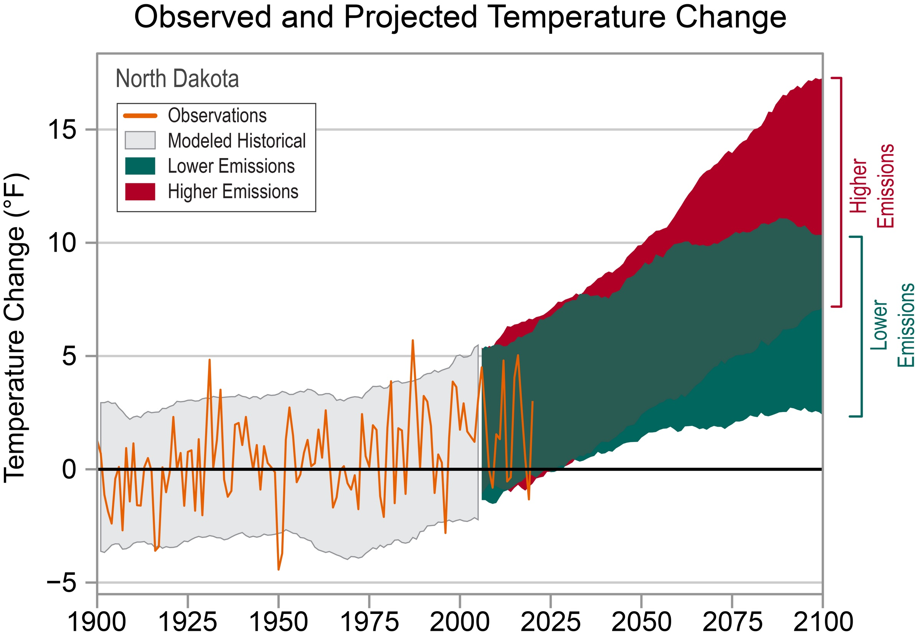
ND Warming

Strategic Plan

SP-05 Overview
Strategic Plan Overview
The Strategic Plan serves as a planning document that outlines the anticipated resources over the course of 5-years from CDBG entitlement funding, program income, and other sources. Additionally, a series of goals is described, illuminating how the City will prioritize available financial resources, geographic priorities, and expected outcomes.
Priorities and goals were determined through analysis of multiple data sources:
- Comprehensive community surveys and meetings
- Interview and consultation with area stakeholders
- Staff recommendations
- Results of previous monitoring of subrecipients
- HUD Annual Homeless Assessment Report
- HUD Worst Case Housing Needs
- Policy Map, Community Profile
- HUD Community Resiliency Kit
- Community Housing Assessment Strategy (CHAS) data
- American Housing Survey (AHS) data
- American Community Survey (ACS) 5-Year Estimates

SP-10 Geographic Priorities – 91.215 (a)(1)
Geographic Area
Table 52 - Geographic Priority Areas
1 | Area Name: | Citywide
1 | Area Type: | Local Target area
1 | Other Target Area Description:
1 | HUD Approval Date:
1 | % of Low/ Mod:
1 | Revital Type: | Comprehensive
1 | Other Revital Description:
1 | Identify the neighborhood boundaries for this target area.
1 | Include specific housing and commercial characteristics of this target area.
1 | How did your consultation and citizen participation process help you to identify this neighborhood as a target area?
1 | Identify the needs in this target area.
1 | What are the opportunities for improvement in this target area?
1 | Are there barriers to improvement in this target area?

General Allocation Priorities
Describe the basis for allocating investments geographically within the jurisdiction (or within the EMSA for HOPWA)
The City did not identify a geographic target area as a basis for funding allocation priorities. Goals are not limited to a specific area within Minot.

SP-25 Priority Needs - 91.215(a)(2)
Priority Needs
Table 53 – Priority Needs Summary
1 | Priority Need Name | Provide Decent Housing
1 | Priority Level | High
1 | Population | Extremely Low  Low  Moderate  Middle  Large Families  Families with Children  Elderly  Public Housing Residents  Chronic Homelessness  Individuals  Families with Children  Mentally Ill  Chronic Substance Abuse  veterans  Persons with HIV/AIDS  Victims of Domestic Violence  Unaccompanied Youth  Elderly  Frail Elderly  Persons with Mental Disabilities  Persons with Physical Disabilities  Persons with Developmental Disabilities  Persons with Alcohol or Other Addictions  Persons with HIV/AIDS and their Families  Victims of Domestic Violence  Non-housing Community Development
1 | Geographic Areas Affected | Citywide
1 | Associated Goals | Planning and Administration  Public Services  Housing
1 | Description | A decent place to live removes the barriers to opportunity, success, and health that have been part of a family's life for years, if not generations. Creating safe and decent places to live can have incredibly positive effects on a family's health, students' study habits, and a neighborhood's overall attractiveness and stability. Decent housing includes a spectrum of solutions: new construction, repair and renovation, housing finance, infrastructure development, and secure land tenure, among others.
1 | Basis for Relative Priority | Providing people with a range of housing choices has many positive aspects – both for the community in general and for individual families. As individuals and families move from one stage of life to the next, various housing types enable them to live in a place that suits their needs while allowing them to reside in the same community, keeping those ties and staying close to family members if they desire.
2 | Priority Need Name | Create A Suitable Living Environment
2 | Priority Level | High
2 | Population | Extremely Low  Low  Moderate  Middle  Large Families  Families with Children  Elderly  Public Housing Residents  Chronic Homelessness  Individuals  Families with Children  Mentally Ill  Chronic Substance Abuse  veterans  Persons with HIV/AIDS  Victims of Domestic Violence  Unaccompanied Youth  Elderly  Frail Elderly  Persons with Mental Disabilities  Persons with Physical Disabilities  Persons with Developmental Disabilities  Persons with Alcohol or Other Addictions  Persons with HIV/AIDS and their Families  Victims of Domestic Violence  Non-housing Community Development
2 | Geographic Areas Affected | Citywide
2 | Associated Goals | Planning and Administration  Public Services  Public Facilities and Infrastructure Improvements  Housing
2 | Description | Create a Suitable Living Environment  A good living environment is essential for good quality of life. A functional and sound living environment allows different people to lead their daily lives and fulfill their basic needs: living, services, working, recreation, hobbies, rest, and privacy.
2 | Basis for Relative Priority | Jobs, family income, transportation costs, and housing are intricately connected. New research has shown that stable families, communities, and housing positively impact economic vitality. Providing opportunities for workers to live in the city where they work positively affects in-commuting and reduces transportation costs.
3 | Priority Need Name | Expand Opportunities for LMI Persons
3 | Priority Level | High
3 | Population | Extremely Low  Low  Moderate  Middle  Large Families  Families with Children  Elderly  Public Housing Residents  Chronic Homelessness  Individuals  Families with Children  Mentally Ill  Chronic Substance Abuse  veterans  Persons with HIV/AIDS  Victims of Domestic Violence  Unaccompanied Youth  Elderly  Frail Elderly  Persons with Mental Disabilities  Persons with Physical Disabilities  Persons with Developmental Disabilities  Persons with Alcohol or Other Addictions  Persons with HIV/AIDS and their Families  Victims of Domestic Violence  Non-housing Community Development
3 | Geographic Areas Affected | Citywide
3 | Associated Goals | Planning and Administration  Public Services  Public Facilities and Infrastructure Improvements
3 | Description | Expanding opportunities to low- and moderate-income persons helps to foster local economic development, neighborhood improvement, and individual self-sufficiency.
3 | Basis for Relative Priority | Expanding opportunities for low- and moderate-income residents helps residents become financially stable and remain in safe and stable housing.

Narrative (Optional)
The City of Minot seeks to encourage viable community development by promoting integrated approaches that provide decent housing, a suitable living environment, and expand economic opportunities for low- and moderate-income persons. The primary means towards this end is the development of partnerships among all levels of government and the private sector, including for-profit and non-profit organizations. Housing and community development are not viewed as separate programs but rather as the various elements that make up a comprehensive vision of community development.

SP-30 Influence of Market Conditions – 91.215 (b)
Influence of Market Conditions
Affordable Housing Type | Market Characteristics that will influence  the use of funds available for housing type
Tenant Based Rental Assistance (TBRA) | The City of Minot acknowledges the high need for decent, affordable housing. However, the city does not receive a HOME allocation and does not have a TBRA program.
TBRA for Non-Homeless Special Needs | The City of Minot acknowledges the high need for decent, affordable housing within the city. The City does not receive a HOME allocation and does not have a TBRA program.
New Unit Production | The City continues to help support the production of new housing in Minot. A portion of the CDBG DR funding received has been utilized for housing stock development,  The City helps to support the production of new residential housing and multifamily construction and will continue with CDBG resources when possible.
Rehabilitation | The City is committed to ensuring that the existing housing stock is safe and livable for low- to moderate-income residents.
Acquisition, including preservation | The City of Minot may utilize strategic acquisitions to help support LIHTC and other affordable housing projects.
Table 54 – Influence of Market Conditions

SP-35 Anticipated Resources - 91.215(a)(4), 91.220(c)(1,2)
Introduction
The City of Minot prioritized goals and objectives for using CDBG funding to strategically and effectively benefit low- and moderate-income residents by increasing decent housing, creating a suitable living environment, and expanding economic opportunities.
The City of Minot follows HUD guidelines and limits public services to no more than 15% and administration to 20% of the annual entitlement.
Anticipated Resources
Program | Source of Funds | Uses of Funds | Expected Amount Available Year 1 |  |  |  | Expected Amount Available Remainder of ConPlan  $ | Narrative Description
Program | Source of Funds | Uses of Funds | Annual Allocation: $ | Program Income: $ | Prior Year Resources: $ | Total:  $ | Expected Amount Available Remainder of ConPlan  $ | Narrative Description
CDBG | public - federal | Acquisition  Admin and Planning  Economic Development  Housing  Public Improvements  Public Services | 331,580 | 0 | 0 | 331,580 | 1,326,320 | The City anticipates receiving $331,580 in annual entitlement from FY2024 - FY2028 for a total of $1,657,900.
Table 55 - Anticipated Resources

Explain how federal funds will leverage those additional resources (private, state and local funds), including a description of how matching requirements will be satisfied
The City of Minot does not receive funding from additional HUD programs, including HOME, HOPWA, or ESG, that may require a match.
The projects outlined in the Strategic Plan, implemented by outside agencies, are anticipated to use CDBG funding to leverage their initial financial resources.
- Affordable housing supply projects are expected to leverage local, state, federal, and/or private funds.
- Subrecipients must report on match support for projects.
If appropriate, describe publically owned land or property located within the jurisdiction that may be used to address the needs identified in the plan

Discussion
The City expects partners to leverage CDBG funding to the fullest extent possible to implement robust programs that will help further the needs of area residents.

SP-40 Institutional Delivery Structure – 91.215(k)
Explain the institutional structure through which the jurisdiction will carry out its consolidated plan including private industry, non-profit organizations, and public institutions.
Responsible Entity | Responsible Entity Type | Role | Geographic Area Served
CITY OF MINOT | Government | Economic Development  Homelessness  Non-homeless special needs  Ownership  Planning  Rental  neighborhood improvements  public facilities  public services | Jurisdiction
Table 56 - Institutional Delivery Structure
Assess of Strengths and Gaps in the Institutional Delivery System

Availability of services targeted to homeless persons and persons with HIV and mainstream services
Homelessness Prevention Services | Available in the Community | Targeted to Homeless | Targeted to People with HIV
Homelessness Prevention Services
Counseling/Advocacy | X | X
Legal Assistance | X
Mortgage Assistance | X
Rental Assistance | X | X
Utilities Assistance | X | X

Street Outreach Services
Law Enforcement
Mobile Clinics
Other Street Outreach Services

Supportive Services
Alcohol & Drug Abuse | X | X
Child Care | X
Education | X
Employment and Employment Training | X
Healthcare | X
HIV/AIDS | X | X | X
Life Skills | X
Mental Health Counseling | X | X
Transportation

Other
Table 57 - Homeless Prevention Services Summary
Describe how the service delivery system including, but not limited to, the services listed above meet the needs of homeless persons (particularly chronically homeless individuals and families, families with children, veterans and their families, and unaccompanied youth)
Health services are available to persons living with HIV through several health providers.
The Tri-State HELP (Housing Environment for Living Positively) HOPWA (Housing Opportunities for Persons With Aids) is a needs-based program for low-income persons living with HIV/AIDS and their families who live in Montana, North Dakota, and South Dakota and need housing assistance and/or related supportive services.
Describe the strengths and gaps of the service delivery system for special needs population and persons experiencing homelessness, including, but not limited to, the services listed above

Provide a summary of the strategy for overcoming gaps in the institutional structure and service delivery system for carrying out a strategy to address priority needs

SP-45 Goals Summary – 91.215(a)(4)
Goals Summary Information
Sort Order | Goal Name | Start Year | End Year | Category | Geographic Area | Needs Addressed | Funding | Goal Outcome Indicator
1 | Planning and Administration | 2024 | 2028 | Affordable Housing  Public Housing  Homeless  Non-Homeless Special Needs  Non-Housing Community Development | Citywide | Provide Decent Housing  Create A Suitable Living Environment  Expand Opportunities for LMI Persons | CDBG: $331,580 | Other:  1 Other
2 | Public Services | 2024 | 2028 | Affordable Housing  Public Housing  Homeless  Non-Homeless Special Needs  Non-Housing Community Development | Citywide | Provide Decent Housing  Create A Suitable Living Environment  Expand Opportunities for LMI Persons | CDBG: $248,685 | Public service activities other than Low/Moderate Income Housing Benefit:  425 Persons Assisted
3 | Public Facilities and Infrastructure Improvements | 2024 | 2028 | Homeless  Non-Homeless Special Needs  Non-Housing Community Development | Citywide | Create A Suitable Living Environment  Expand Opportunities for LMI Persons | CDBG: $527,635 | Public Facility or Infrastructure Activities other than Low/Moderate Income Housing Benefit:  7650 Persons Assisted
4 | Housing | 2024 | 2028 | Affordable Housing | Citywide | Provide Decent Housing  Create A Suitable Living Environment | CDBG: $550,000 | Homeowner Housing Added:  2 Household Housing Unit  Homeowner Housing Rehabilitated:  18 Household Housing Unit
Table 58 – Goals Summary

Goal Descriptions

1 | Goal Name | Planning and Administration
1 | Goal Description | General Administrative funds will pay reasonable program administrative costs and carrying charges related to planning and executing community development activities. Administering federal funds and ensuring compliance is critical for utilizing Federal resources. Minot is committed to using CDBG entitlement funding for administration to help continue growing an efficient, effective, and resourceful community development program.  Minot may have administration projects that include, but are not limited to:  - General management, oversight, and coordination  - Providing local officials and citizens with information about the CDBG program  - Preparing budgets and schedules  - Preparing reports and other HUD-required documents  - Program planning  - Public Information  - Monitoring program activities  - Fair Housing activities  - Indirect costs  - Submission of applications for Federal programs
2 | Goal Name | Public Services
2 | Goal Description | Public services are an integral part of a comprehensive community development strategy. Public Service activities provide a wide range of activities that address needs in the community provided for the target population. Public services can strengthen communities by addressing the needs of specific populations. They can address a range of individual needs and increase CDBG dollars' impact by complementing other activities.  The City of Minot may allocate up to 15% of CDBG funds to public services programs that provide supportive services to low- to moderate-income persons or prevent homelessness. In general, these services are provided by local non-profit partners. This funding is capped at 15% of the CDBG entitlement plus program income.  Minots's goal to improve and provide public services may include, but is not limited to:  - Employment services  - Crime prevention and public safety  - Child care  - Health services  - Substance use services  - Fair housing counseling  - Education programs  - Energy conservation  - Services for homeless persons  - Services for seniors  - Welfare services (excluding income payments)  - Recreational services
3 | Goal Name | Public Facilities and Infrastructure Improvements
3 | Goal Description | Public Infrastructure Improvements will focus on safe and accessible infrastructure essential to the quality of life and building communities that support community diversity and stability. Public infrastructure improvements will generally include the acquisition, construction, reconstruction, and installation of public infrastructure.  Minot's goal to improve and expand public infrastructure may include, but is not limited to:  - ADA Improvements  - Sidewalks  - Curb cuts  Public Facilities and Improvements are publicly-owned facilities and infrastructure such as streets, playgrounds, underground utilities, and buildings owned by nonprofits open to the general public. Safe and accessible infrastructure is essential to the quality of life and building communities that support community diversity and stability. Public facilities and public improvements are generally interpreted to include all facilities and improvements that are publicly owned or owned by a nonprofit and open to the general public. Acquisition, construction, reconstruction, rehabilitation, and installation of public facilities and improvements are eligible activities.  Minot's goal to improve and expand public facilities may include, but is not limited to:  - Senior Centers  - Homeless and Domestic Violence Facilities  - Neighborhood Facilities  - Health Facilities
4 | Goal Name | Housing
4 | Goal Description | The City prioritized goals and objectives for using CDBG funding to strategically and effectively benefit low- and moderate-income residents by increasing access to decent housing and creating a suitable living environment while expanding economic opportunities for LMI persons. Minot is committed to improving and expanding access to safe and affordable housing for low- and moderate-income (LMI) residents. Affordable and safe housing helps to provide financial stability, reduces the chances of a person becoming homeless, and promotes housing sustainability.  Minot's projects to improve housing sustainability may include, but are not limited to:  - Homeownership Assistance  - Rehabilitation (single-unit residential and/or multi-family residential)  - Energy efficiency improvements  - The administrative cost for rehabilitation activities  - Lead-based paint testing/abatement  - Housing counseling
Estimate the number of extremely low-income, low-income, and moderate-income families to whom the jurisdiction will provide affordable housing as defined by HOME 91.315(b)(2)
During the 2022-2026 Consolidated Plan period, the City of Minot will have projects that help to support affordable housing for low- to moderate-income residents.
- Homeowner Housing Rehabilitated - 18 Households Assisted
- Lead-Based-Paint Mitigation - 3 Households Assisted as part of a rehab activity
- Homeowner Housing Units Added - 2 Units
Other programs will help support low- and moderate-income residents.
- Public Facilities and Infrastructure projects - 7,650 persons assisted
- Public services - 425 persons assisted

SP-50 Public Housing Accessibility and Involvement – 91.215(c)
Need to Increase the Number of Accessible Units (if Required by a Section 504 Voluntary Compliance Agreement)
Section 504 of the Rehabilitation Act of 1973 is a federal law, codified at 29 U.S.C. § 794, that prohibits discrimination based on disability in federally-assisted programs or activities. Specifically, Section 504 states, "No otherwise qualified individual with a disability in the United States. . .shall, solely by reason of her or his disability, be excluded from participation in, be denied the benefits of, or be subjected to discrimination under any program, service or activity receiving federal financial assistance or under any program or activity conducted by any Executive agency or by the United States Postal Service." This means that Section 504 prohibits discrimination based on disability in any program or activity that receives financial assistance from any federal agency, including HUD, as well as in programs conducted by federal agencies, including HUD.
An individual with a disability is any person who has a physical or mental impairment that substantially limits one or more major life activities. The term physical or mental impairment may include, but is not limited to, conditions such as visual or hearing impairment, mobility impairment, HIV infection, developmental disabilities, drug addiction, or mental illness. In general, the definition of "person with disabilities" does not include current users of illegal controlled substances. However, individuals would be protected under Section 504 (as well as the ADA) if the purpose of the specific program or activity is to provide health or rehabilitation services to such individuals.
The term major life activity may include, for example, seeing, hearing, walking, breathing, performing manual tasks, caring for one's self, learning, speaking, or working. This list is not exhaustive. Section 504 also protects persons with a record of such impairment or who are regarded as having such an impairment.
Activities to Increase Resident Involvements
Minot Housing Authority is committed to providing quality, affordable housing to residents. Staff and residents are working together and making new strides in creating safer communities.
Minot Housing Authority is working the way out of substandard status as of 2023.
Is the public housing agency designated as troubled under 24 CFR part 902?
No
Plan to remove the ‘troubled’ designation

SP-55 Barriers to affordable housing – 91.215(h)
Barriers to Affordable Housing

Strategy to Remove or Ameliorate the Barriers to Affordable Housing
Although federal policies play an important role in influencing the availability of affordable housing the supply of affordable housing depends less on federal policies than on local planning practices, policies, and community engagement. Many local planning procedures currently in place enable community opposition that stalls housing production. Reshaping local regulations allows jurisdictions to make a lasting impact on the supply of affordable housing.
According to Brian Montgomery, former Federal Housing Administration commissioner and assistant secretary for housing, constraints on housing not only reduce the supply of affordable housing but also increase the number of households that are cost-burdened, spending more than 30 percent of their income on rent.
Land-use policies and zoning regulations constrain the supply of affordable housing. Density limits, height restrictions, parking requirements, lengthy permitting and approval processes, and community opposition all contribute to increased housing prices.
HUD, PD&R Edge, "Regulatory Barriers and Affordable Housing Quarterly Update"
The City of Minot seeks to foster an environment of opportunity, innovation, and sustainability in the housing market by planning for and supporting housing options that help increase the HOI while protecting property rights.
The city completed a broad community Housing Study in the spring of 2024.
Recommendations relate to:
- Unit Size
- Increasing homeownership options
- Additional housing across types
- Address gap for affordable units
Housing cost was rated the highest concern among over 800 survey respondents.
The City of Minot will use this robust study to help guide housing production priorities over the next decade.

SP-60 Homelessness Strategy – 91.215(d)
Reaching out to homeless persons (especially unsheltered persons) and assessing their individual needs

Addressing the emergency and transitional housing needs of homeless persons
Through consultation with stakeholders, the city has identified year-round emergency shelter and transitional housing as a priority.
Currently DV victims have access to emergency shelter and limited transitional housing rooms
Helping homeless persons (especially chronically homeless individuals and families, families with children, veterans and their families, and unaccompanied youth) make the transition to permanent housing and independent living, including shortening the period of time that individuals and families experience homelessness, facilitating access for homeless individuals and families to affordable housing units, and preventing individuals and families who were recently homeless from becoming homeless again.

Help low-income individuals and families avoid becoming homeless, especially extremely low-income individuals and families who are likely to become homeless after being discharged from a publicly funded institution or system of care, or who are receiving assistance from public and private agencies that address housing, health, social services, employment, education or youth needs

SP-65 Lead based paint Hazards – 91.215(i)
Actions to address LBP hazards and increase access to housing without LBP hazards
How are the actions listed above related to the extent of lead poisoning and hazards?
How are the actions listed above integrated into housing policies and procedures?

SP-70 Anti-Poverty Strategy – 91.215(j)
Jurisdiction Goals, Programs and Policies for reducing the number of Poverty-Level Families
The needs, goals, and projects outlined in the Consolidated Plan work together to help reduce poverty. While poverty is a function of factors (many of which are) beyond the control of City policies, providing Minot residents with affordable, quality housing in economically diverse neighborhoods can foster economic mobility and soften the impact of poverty.
How are the Jurisdiction poverty reducing goals, programs, and policies coordinated with this affordable housing plan
The 2024-2028 Consolidated Plan has goals designed to help address and reduce poverty in Minot. The goals outlined in Consolidated Plan are focused solely on helping improve the lives of low- and moderate-income residents.
Goal: Housing
Improving and preserving the existing house stock is key to increasing the number of affordable housing units in Minot. The City will help ensure that low- to moderate-income residents have safe and livable housing. Housing rehabilitation projects and emergency home repair ensure that residents most at risk of having deferred home maintenance and unsafe living environments can remain in their homes. Additionally, homeownership programs help low- to moderate-income residents transition into more stable homeownership.
Minot is committed to improving and increasing access to safe and affordable housing for low- and moderate-income (LMI) residents. Affordable and safe housing helps to provide financial stability, reduces the chances of a person becoming homeless, and promotes housing sustainability. The City prioritized goals and objectives for using CDBG funding to benefit strategically and effectively low- and moderate-income residents by increasing access to decent housing and creating a suitable living environment while expanding economic opportunities for LMI persons.
Goal: Public Services
The City will work to utilize CDBG funds for public service. Projects will help low- to moderate-income residents with the impacts of domestic violence, homelessness, and other key community services. These projects may vary over the course of the consolidated plan. Still, the focus will remain on ensuring that low- and moderate-income residents have the support they need to ensure their safety, access to affordable housing, and increased access to economic improvements.
Public services are an integral part of a comprehensive community development strategy. Public Service activities provide a wide range of activities that address needs in the community provided for the target population. In general, these services are provided by local non-profit partners. This funding is capped at 15% of the CDBG entitlement plus 15 % of previous year program income, if any.
Goal: Public Facilities and Infrastructure Improvements
Public Infrastructure Improvements will focus on safe and accessible infrastructure essential to the quality of life and building communities that support community diversity and stability. In general, public infrastructure improvements will include acquisition, construction, reconstruction, and installation of public infrastructure and facilities.

SP-80 Monitoring – 91.230
Describe the standards and procedures that the jurisdiction will use to monitor activities carried out in furtherance of the plan and will use to ensure long-term compliance with requirements of the programs involved, including minority business outreach and the comprehensive planning requirements
The City of Minot will work closely with HUD to ensure that all statutory requirements are being met and that information being reported in the City's CAPER is accurate and complete. Additionally, the City will participate in online and on-site HUD training regularly.
Monitoring is an ongoing, two-way communication process between the City and recipients. The goal of monitoring is to encourage the completion of projects within the contract period while ensuring that project objectives are met. Successful monitoring involves frequent telephone contacts, written communications, analysis of reports and audits, and periodic meetings.
Monitoring is the principal means by which the City:
- Ensures that HUD-funded programs and technical areas are carried out efficiently, effectively, and in compliance with applicable laws and regulations
- Assists subrecipients in improving their performance, developing or increasing capacity, and augmenting their management and technical skills
- Stays abreast of the efficacy and technical areas of HUD CDBG programs.
- Documents the effectiveness of programs administered by the subrecipients.
The City performs a risk assessment of subrecipients to identify which subrecipients require comprehensive monitoring. High-risk subrecipients include those that are:
- New to the CDBG program;
- Experience turnover in key staff positions or change in goals or directions;
- Encountering complaints and/or bad press;
- Previous compliance or performance problems including failure to meet schedules, submit timely reports, or clear monitoring or audit findings;
- Carrying out high-risk activities (economic development, job creation, etc.);
- Undertaking multiple CDBG-funded activities for the first time
The City and CDBG subrecipients are held accountable to program goals through a range of monitoring and timeliness activities.
Monitoring Visits: The City will conduct an annual visit or desk monitoring of all subrecipients. On-site visits may include an on-site interview, inspection of financial and client records relating to the CDBG funding provided, evaluation of the subrecipient's performance, analysis of the strengths and weaknesses of the program, assurance that activities comply with the Action Plan, and a report by the subrecipients of any needs, such as technical assistance or areas for program enhancement.
Evaluating Performance: Performance is measured against the goals identified in the initial CDBG subrecipient agreement. During the annual monitoring visit, the subrecipient has an opportunity to explain how goals and objectives for the year were achieved or why their goals were not reached. A follow-up letter to each subrecipient concludes the annual monitoring visit process. The letter summarizes the findings of the visit, and a copy is kept on file for reference.
Financial Management: Financial management oversight activities are also conducted each time a subrecipient requests reimbursement. City staff will verify that the subrecipient has started their program and is progressing toward their goals before approving a reimbursement request. Subrecipients also must submit the appropriate documentation to be reimbursed.
Data Management: The City will update the program and financial information in the Integrated Disbursement and Information System (IDIS) regularly to meet HUD's Timeliness requirements. The City will obtain program information from the monthly or quarterly reports received from the CDBG subrecipients.

Expected Resources

AP-15 Expected Resources – 91.220(c)(1,2)
Introduction
The City of Minot prioritized goals and objectives for using CDBG funding to strategically and effectively benefit low- and moderate-income residents by increasing decent housing, creating a suitable living environment, and expanding economic opportunities.
The City of Minot follows HUD guidelines and limits public services to no more than 15% and administration to 20% of the annual entitlement.
Anticipated Resources
Program | Source of Funds | Uses of Funds | Expected Amount Available Year 1 |  |  |  | Expected Amount Available Remainder of ConPlan  $ | Narrative Description
Program | Source of Funds | Uses of Funds | Annual Allocation: $ | Program Income: $ | Prior Year Resources: $ | Total:  $ | Expected Amount Available Remainder of ConPlan  $ | Narrative Description
CDBG | public - federal | Acquisition  Admin and Planning  Economic Development  Housing  Public Improvements  Public Services | 331,580 | 0 | 0 | 331,580 | 1,326,320 | The City anticipates receiving $331,580 in annual entitlement from FY2024 - FY2028 for a total of $1,657,900.
Table 59 - Expected Resources – Priority Table

Explain how federal funds will leverage those additional resources (private, state and local funds), including a description of how matching requirements will be satisfied
The City of Minot does not receive funding from additional HUD programs, including HOME, HOPWA, or ESG, that may require a match.
The projects outlined in the Strategic Plan, implemented by outside agencies, are anticipated to use CDBG funding to leverage their initial financial resources.
- Affordable housing supply projects are expected to leverage local, state, federal, and/or private funds.
- Subrecipients must report on match support for projects.

If appropriate, describe publically owned land or property located within the jurisdiction that may be used to address the needs identified in the plan

Discussion
The City expects partners to leverage CDBG funding to the fullest extent possible to implement robust programs that will help further the needs of area residents.

Annual Goals and Objectives

AP-20 Annual Goals and Objectives
Goals Summary Information
Sort Order | Goal Name | Start Year | End Year | Category | Geographic Area | Needs Addressed | Funding | Goal Outcome Indicator
1 | Planning and Administration | 2024 | 2028 | Affordable Housing  Public Housing  Homeless  Non-Homeless Special Needs  Non-Housing Community Development | Citywide | Create A Suitable Living Environment  Expand Opportunities for LMI Persons | CDBG: $66,316 | Other: 1 Other
2 | Public Services | 2024 | 2028 | Affordable Housing  Public Housing  Homeless  Non-Homeless Special Needs  Non-Housing Community Development | Citywide | Create A Suitable Living Environment  Expand Opportunities for LMI Persons | CDBG: $49,737 | Public service activities other than Low/Moderate Income Housing Benefit: 80 Persons Assisted
3 | Public Facilities and Infrastructure Improvements | 2024 | 2028 | Homeless  Non-Homeless Special Needs  Non-Housing Community Development | Citywide | Create A Suitable Living Environment  Expand Opportunities for LMI Persons | CDBG: $105,527 | Public Facility or Infrastructure Activities other than Low/Moderate Income Housing Benefit: 530 Persons Assisted
4 | Housing | 2024 | 2028 | Affordable Housing | Citywide | Provide Decent Housing | CDBG: $110,000 | Homeowner Housing Added: 1 Household Housing Unit  Homeowner Housing Rehabilitated: 3 Household Housing Unit
Table 60 – Goals Summary

Goal Descriptions

1 | Goal Name | Planning and Administration
1 | Goal Description | General Administrative funds will pay reasonable program administrative costs and carrying charges related to the planning and execution of community development activities. Administering federal funds and ensuring compliance is critical for utilizing Federal resources. Minot is committed to using CDBG entitlement funding for administration to help grow a community development program that is efficient, effective, and resourceful.  Minot may have administration projects that include, but are not limited to:  - General management, oversight, and coordination  - Providing local officials and citizens with information about the CDBG program  - Preparing budgets and schedules  - Preparing reports and other HUD-required documents  - Program planning  - Public Information  - Monitoring program activities  - Fair Housing activities  - Indirect costs  - Submission of applications for Federal programs
2 | Goal Name | Public Services
2 | Goal Description | Public services are an integral part of a comprehensive community development strategy. Public Service activities provide a wide range of activities that address needs in the community provided for the target population. Public services can strengthen communities by addressing the needs of specific populations. They can address a range of individual needs and increase CDBG dollars' impact by complementing other activities.  The City of Minot may allocate up to 15% of CDBG funds to public services programs that provide supportive services to low- to moderate-income persons or prevent homelessness. In general, these services are provided by local non-profit partners. This funding is capped at 15% of the CDBG entitlement plus program income.  Minots's goal to improve and provide public services may include, but is not limited to:  - Employment services  - Crime prevention and public safety  - Child care  - Health services  - Substance use services  - Fair housing counseling  - Education programs  - Energy conservation  - Services for homeless persons  - Services for seniors  - Welfare services (excluding income payments)  - Recreational services
3 | Goal Name | Public Facilities and Infrastructure Improvements
3 | Goal Description | Public Infrastructure Improvements will focus on safe and accessible infrastructure essential to the quality of life and building communities that support community diversity and stability. Public infrastructure improvements will generally include the acquisition, construction, reconstruction, and installation of public infrastructure.  Minot's goal to improve and expand public infrastructure may include, but is not limited to:  - ADA Improvements  - Sidewalks  - Curb cuts  Public Facilities and Improvements are publicly-owned facilities and infrastructure such as streets, playgrounds, underground utilities, and buildings owned by nonprofits open to the general public. Safe and accessible infrastructure is essential to the quality of life and building communities that support community diversity and stability. Public facilities and public improvements are generally interpreted to include all facilities and improvements that are publicly owned or owned by a nonprofit and open to the general public. Acquisition, construction, reconstruction, rehabilitation, and installation of public facilities and improvements are eligible activities.  Minot's goal to improve and expand public facilities may include, but is not limited to:  - Senior Centers  - Homeless and Domestic Violence Facilities  - Neighborhood Facilities  - Health Facilities
4 | Goal Name | Housing
4 | Goal Description | The City prioritized goals and objectives for using CDBG funding to strategically and effectively benefit low- and moderate-income residents by increasing access to decent housing and creating a suitable living environment while expanding economic opportunities for LMI persons. Minot is committed to improving and expanding access to safe and affordable housing for low- and moderate-income (LMI) residents. Affordable and safe housing helps provide financial stability, reduces the chances of a person becoming homeless, and promotes sustainability of housing.  Minot's projects to improve housing sustainability may include, but are not limited to:  - Homeownership Assistance  - Rehabilitation (single-unit residential and/or multi-family residential)  - Energy efficiency improvements  - The administrative cost for rehabilitation activities  - Lead-based paint testing/abatement  - Housing counseling

Projects

AP-35 Projects – 91.220(d)
Introduction
Minot will allocate $331,580.00, entire first year award, in Community Development Block Grant (CDBG) funds for July 1, 2024 to June 30, 2025, funding cycle.
Over the next year, CDBG funds will be utilized as follows:
The following projects will be funded in the 2024 program year using CDBG dollars:
- Administration and Planning - $66,316
- Public Services - $49,737
- Public Facilities and Improvements - $105,527
- Housing - $110,00

Projects
# | Project Name
1 | 2024 Administration and Planning
2 | 2024 Public Services
3 | 2024 Public Facilities and Infrastructure Improvements
4 | 2024 Housing
Table 61 – Project Information

Describe the reasons for allocation priorities and any obstacles to addressing underserved needs
Federal CDBG funds are intended to provide low-and moderate-income households with viable communities, including decent housing, a suitable living environment, and extended economic opportunities. Eligible activities include housing rehabilitation and preservation, homeownership opportunities, public services, community infrastructure improvements, planning, and administration.
The system for establishing the priority for the selection of these projects is predicated upon the following criteria:
- Meeting the statutory requirements of the CDBG program
- Meeting the needs of low- and moderate-income residents
- Coordination and leveraging of resources
- Response to expressed community needs
- Sustainability and/or long-term impact, and
- The ability to demonstrate measurable progress and success.
The primary obstacles to meeting underserved needs are the limited resources available to address identified priorities. When feasible, the City of Minot will partner with other public agencies and nonprofit organizations to leverage resources and maximize outcomes in housing and community development. In the end, however, the need far exceeds the funding available from all sources combined.

AP-38 Project Summary
Project Summary Information

1 | Project Name | 2024 Administration and Planning
1 | Target Area | Citywide
1 | Goals Supported | Planning and Administration
1 | Needs Addressed | Provide Decent Housing  Create A Suitable Living Environment  Expand Opportunities for LMI Persons
1 | Funding | CDBG: $66,316
1 | Description | The City has planned for administrative services which include providing technical assistance, planning activities, fair housing activities, and general administrative services for PY24. These activities are planned to date, and the City may make changes as needed that fit the description of this project.
1 | Target Date | 6/30/2025
1 | Estimate the number and type of families that will benefit from the proposed activities | All residents in Minot benefit directly or indirectly from the Community Development Block Grant (CDBG) program.
1 | Location Description | Citywide
1 | Planned Activities | General Administrative funds will provide for payment of reasonable program administrative costs and carrying charges related to the planning and execution of community development activities. Administering federal funds and ensuring compliance is a critical part of utilizing federal resources. Minot is committed to using CDBG entitlement funding for administration to help to grow a community development program that is efficient, effective, and resourceful.  Minot may have administration projects that include, but are not limited to:  - General management, oversight, and coordination  - Providing local officials and citizens with information about the CDBG program  - Preparing budgets and schedules  - Preparing reports and other HUD-required documents  - Program planning  - Public Information  - Monitoring program activities  - Fair Housing activities  - Indirect costs  - Submission of applications for Federal programs
2 | Project Name | 2024 Public Services
2 | Target Area | Citywide
2 | Goals Supported | Public Services
2 | Needs Addressed | Provide Decent Housing  Create A Suitable Living Environment  Expand Opportunities for LMI Persons
2 | Funding | CDBG: $49,737
2 | Description | Public services are an integral part of a comprehensive community development strategy. Public Service activities provide a wide range of activities that address needs in the community provided for the target population. Public services can strengthen communities by addressing the needs of specific populations. They can address various individual needs and increase CDBG dollars' impact by complementing other activities. The City of Minot may allocate up to 15% of CDBG funds to public services programs that provide supportive services to low- to moderate-income persons or prevent homelessness. In general, these services are provided by local non-profit partners. This funding is capped at 15% of the CDBG entitlement plus program income from the previous year. Minot's goal to improve and provide public services may include but is not limited to: employment services, crime prevention and public safety, child care, health services, substance use services, fair housing counseling, education programs, energy conservation, services for homeless persons, services for seniors, welfare services (excluding income payments), and recreational services.
2 | Target Date | 6/30/2025
2 | Estimate the number and type of families that will benefit from the proposed activities | City of Minot staff is consulting service providers to identify key gaps in priority public services for city residents.  An estimated 425 unduplicated LMI people will be served in the first year as a CDBG Entitlement.
2 | Location Description | Public Services will be available citywide.
2 | Planned Activities
3 | Project Name | 2024 Public Facilities and Infrastructure Improvements
3 | Target Area | Citywide
3 | Goals Supported | Public Facilities and Infrastructure Improvements
3 | Needs Addressed | Create A Suitable Living Environment
3 | Funding | CDBG: $105,527
3 | Description | Public Facilities and Improvements are publicly-owned facilities and infrastructure such as streets, playgrounds, underground utilities, and buildings owned by nonprofits open to the general public. Safe and accessible infrastructure is essential to the quality of life and building communities that support community diversity and stability. Public facilities and public improvements are generally interpreted to include all facilities and improvements that are publicly owned or owned by a nonprofit and open to the general public. Acquisition, construction, reconstruction, rehabilitation, and installation of public facilities and improvements are eligible activities. Minot's goal to improve and expand public facilities may include but is not limited to ADA Improvements, senior centers, homeless and domestic violence facilities, neighborhood facilities, and health facilities. Public Infrastructure Improvements will focus on safe and accessible infrastructure essential to the quality of life and building communities that support community diversity and stability. Public infrastructure improvements will generally include the acquisition, construction, reconstruction, and installation of public infrastructure. Minot's goal to improve and expand public infrastructure may include but is not limited to ADA Improvements, sidewalks, and curb cuts.
3 | Target Date | 6/30/2025
3 | Estimate the number and type of families that will benefit from the proposed activities | The City estimates 530 individuals will benefit from PY 2024 Public Facilities and Infrastructure activities.  Staff is working with key stakeholders to identify projects that are critical to continued partner/city success, may have a funding gap, impact LMI residents, and are able to meet program requirements.
3 | Location Description | Improvements may be made citywide as eligible activities are identified.
3 | Planned Activities | The City plans to invest in public infrastructure and facility improvements that will benefit Minot residents in greatest need.  Work with internal and external stakeholders continues as Minot staff review needs and opportunities to impact LMI residents with vital improvements.
4 | Project Name | 2024 Housing
4 | Target Area | Citywide
4 | Goals Supported | Housing
4 | Needs Addressed | Provide Decent Housing
4 | Funding | CDBG: $110,000
4 | Description | The City prioritized goals and objectives for using CDBG funding to strategically and effectively benefit low- and moderate-income residents by increasing access to decent housing and creating a suitable living environment while expanding economic opportunities for LMI persons. Minot is committed to improving and expanding access to safe and affordable housing for low- and moderate-income (LMI) residents. Affordable and safe housing helps to provide financial stability, reduces the chances of a person becoming homeless, and promotes housing sustainability.
4 | Target Date | 6/30/2025
4 | Estimate the number and type of families that will benefit from the proposed activities | The City estimates assisting the following activities;  - Create new homeownership opportunities, either through homebuyer assistance or eligible redevelopment activities - 1 household assisted  - Home Repair Loan Program - 3 households assisted  Other eligible activities may be considered, as opportunity is available.
4 | Location Description | Activities may be undertaken throughout the City of Minot
4 | Planned Activities | The City of Minot is working with staff and stakeholders to;  - Create a CDBG Home Repair Loan Program  - Target new LMI homeownership opportunities (homebuyer assistance, property acquisition...)  Other eligible housing activities may be undertaken. Opportunities to assist LMI multifamily development are under consideration. These activities typically take multiple years to develop.

AP-50 Geographic Distribution – 91.220(f)
Description of the geographic areas of the entitlement (including areas of low-income and minority concentration) where assistance will be directed
The projects in PY 2024 do not emphasize any one geographic area of Minot. The City does not have a singular concentration of low- to moderate-income residents. Funds are generally dispersed out geographically to have the most significant impact.
While some projects may focus on a low- to moderate-income area (LMA), they are not part of a greater neighborhood plan.
Geographic Distribution
Target Area | Percentage of Funds
Table 62 - Geographic Distribution

Rationale for the priorities for allocating investments geographically
The City did not identify a geographic target area as a basis for funding allocation priorities. Goals and projects are not limited to a specific area within the City.
Discussion
All projects supported with CDBG funds are within the Minot city limits. The projects listed in the 2024 Action Plan will benefit low- and moderate-income residents throughout the City of Minot.

Affordable Housing

AP-55 Affordable Housing – 91.220(g)
Introduction

One Year Goals for the Number of Households to be Supported
Homeless | 0
Non-Homeless | 425
Special-Needs | 0
Total | 425
Table 64 - One Year Goals for Affordable Housing by Support Requirement

One Year Goals for the Number of Households Supported Through
Rental Assistance | 0
The Production of New Units | 1
Rehab of Existing Units | 3
Acquisition of Existing Units | 0
Total | 4
Table 65 - One Year Goals for Affordable Housing by Support Type
Discussion

AP-60 Public Housing – 91.220(h)
Introduction
Actions planned during the next year to address the needs to public housing
Actions to encourage public housing residents to become more involved in management and participate in homeownership
If the PHA is designated as troubled, describe the manner in which financial assistance will be provided or other assistance
Discussion

AP-65 Homeless and Other Special Needs Activities – 91.220(i)
Introduction
The City is not eligible to receive other HUD funds, including HOME, ESG, or HOPWA. The Continuum of Care plan funds are distributed with input from stakeholders.
Describe the jurisdictions one-year goals and actions for reducing and ending homelessness including
Reaching out to homeless persons (especially unsheltered persons) and assessing their individual needs
The City of Minot will continue to work with the Continuum of Care and local partners to reach the local homeless population and assess their needs. The City remains committed to helping residents maintain stable housing and assisting individuals who are already experiencing homelessness in transitioning into housing.
Addressing the emergency shelter and transitional housing needs of homeless persons

Helping homeless persons (especially chronically homeless individuals and families, families with children, veterans and their families, and unaccompanied youth) make the transition to permanent housing and independent living, including shortening the period of time that individuals and families experience homelessness, facilitating access for homeless individuals and families to affordable housing units, and preventing individuals and families who were recently homeless from becoming homeless again

Helping low-income individuals and families avoid becoming homeless, especially extremely low-income individuals and families and those who are: being discharged from publicly funded institutions and systems of care (such as health care facilities, mental health facilities, foster care and other youth facilities, and corrections programs and institutions); or, receiving assistance from public or private agencies that address housing, health, social services, employment, education, or youth needs

Discussion

AP-75 Barriers to affordable housing – 91.220(j)
Introduction:
Actions it planned to remove or ameliorate the negative effects of public policies that serve as barriers to affordable housing such as land use controls, tax policies affecting land, zoning ordinances, building codes, fees and charges, growth limitations, and policies affecting the return on residential investment
Discussion:

AP-85 Other Actions – 91.220(k)
Introduction:
The City of Minot will help to assist low- and moderate-income residents in Minot in the 2024 program year.
Minot is committed to improving and increasing access to safe and affordable housing for low- and moderate-income (LMI) residents. Affordable and safe housing helps to provide financial stability, reduces the chances of a person becoming homeless, and promotes housing sustainability. The City prioritized goals and objectives for using CDBG funding to benefit strategically and effectively for low- and moderate-income residents by increasing access to decent housing and creating a suitable living environment while expanding economic opportunities for LMI persons.
Public services are an integral part of a comprehensive community development strategy. Public Service activities provide a wide range of activities that address needs in the community provided for the target population. Public services can strengthen communities by addressing the needs of specific populations. They can address a range of individual needs and increase CDBG dollars' impact by complementing other activities.
Public Infrastructure Improvements will focus on safe and accessible infrastructure essential to the quality of life and building communities that support community diversity and stability. Public infrastructure improvements generally include the acquisition, construction, reconstruction, and installation of public infrastructure.
The City's CDBG funds are 100% directed toward activities that assist low- to moderate-income residents.
The City of Minot is involved in several efforts to address the needs of the underserved and promote efforts to coordinate the many components related to housing, suitable living environments, and promoting safer living environments.
Actions planned to address obstacles to meeting underserved needs
The primary obstacle to meeting underserved needs is the lack of identified and available resources. To overcome this obstacle, the City will continue to pursue creative partnerships, both financially and structurally, to leverage available funds
The City will continue to seek ways to expand how the City of Minot informs underserved residents about the financial and informational resources available through the CDBG program.
Actions planned to foster and maintain affordable housing
The City of Minot will leverage CDBG funding to encourage the development of affordable housing units within the City of Minot. Specifically, the CDBG program will provide monetary and non-monetary support for projects that will increase the number of housing units made available to low- to moderate-income households and keep the units affordable for a specified time into the future.
The City of Minot will support the owner-occupied housing rehabilitation programs.
Actions planned to reduce lead-based paint hazards
The U. S. Department of Housing and Urban Development issued Title X in 1992 to protect young children and families from lead-based paint hazards. The City of Minot will take steps to ensure its regulations are in compliance. Revised program procedures and documents include additional steps for providing notification, identifying lead hazards, performing lead hazard reduction, using safe work practices, and achieving clearance.
As part of the environmental review process, all existing housing that will be repaired or rehabilitated with CDBG funds is screened for lead paint hazards if built before 1978. Once all work is completed, houses are then re-evaluated and must pass a lead-based paint clearance test to ensure the mitigation efforts are effective.
City staff will attend HUD-sponsored lead-based paint training online and when offered virtually or in person to become more familiar with the requirements and their implementation.
Actions planned to reduce the number of poverty-level families
The City’s plan has three primary components:
- Support activities that increase the number of jobs in Minot, especially for low- to moderate-income residents
- Ensure that a wide variety of housing opportunities are available
- Provide supportive services to residents in poverty.
These all support the City’s goal of helping residents and families achieve self-sufficiency.
For those residents who cannot work (low-income frail elderly, persons with disabilities), the City’s public housing authority and Section 8 voucher providers are vital for those households to avoid homelessness.
A further strategy to reduce the number of poverty-level families includes efforts to diversify Minot’s economy through Economic Development activities, increasing family wage jobs, and expanding the local job base.
Over recent years, Economic Development staff have worked to bring new job opportunities and opportunities to continue educational advancement in or out of the workplace. This is crucial as the area struggles with boom-bust cycles for oil and other industries.
Actions planned to develop institutional structure
The City’s Office of Resilience is responsible for developing and monitoring the Consolidated Plan, the Annual Action Plan, the year-end CAPER report, IDIS reporting process, and sub-recipient compliance monitoring. Staff will carry out the priorities identified in the planning process with assistance from the Economic Development, Engineering, Building, Public Works, Parks, and Public Safety Departments. They will conduct Citizen Participation and Fair Housing outreach and implementation activities.
When applicable and funding allows, City staff will attend relevant CDBG training to help create a broader institutional knowledge base of the CDBG program.
Actions planned to enhance coordination between public and private housing and social service agencies
The City of Minot will continue actively encouraging coordination between public and private housing and social service agencies.
Continued efforts will be made to identify opportunities for service providers to expand services where needed while minimizing the duplication of efforts.
Private businesses are also encouraged to participate in discussions relative to the housing and social service provider needs.
Discussion:
As a new CDBG Entitlement community, the City of Minot is committed to building a robust, efficient, and compliant program targeted at meeting the needs of the most vulnerable community members.

Program Specific Requirements
AP-90 Program Specific Requirements – 91.220(l)(1,2,4)
Introduction:
The City of Minot does not expect to generate program income CDBG activities during PY 2024.. No float-funded activities are included in this Action Plan. The City has never received guaranteed proceeds from Section 108 loan, nor has surplus funds from any federal urban renewal settlements.
Community Development Block Grant Program (CDBG)
Reference 24 CFR 91.220(l)(1)
Projects planned with all CDBG funds expected to be available during the year are identified in the Projects Table. The following identifies program income that is available for use that is included in projects to be carried out.

1. The total amount of program income that will have been received before the start of the next program year and that has not yet been reprogrammed | 0
2. The amount of proceeds from section 108 loan guarantees that will be used during the year to address the priority needs and specific objectives identified in the grantee's strategic plan. | 0
3. The amount of surplus funds from urban renewal settlements | 0
4. The amount of any grant funds returned to the line of credit for which the planned use has not been included in a prior statement or plan | 0
5. The amount of income from float-funded activities | 0
Total Program Income: | 0

Other CDBG Requirements
1. The amount of urgent need activities | 0

<TYPE=[text] REPORT_GUID=[A698417B4C924AE0218B42865313DACF] DELETE_TABLE_IF_EMPTY=[YES]>
2. The estimated percentage of CDBG funds that will be used for activities that benefit persons of low and moderate income. Overall Benefit - A consecutive period of one, two or three years may be used to determine that a minimum overall benefit of 70% of CDBG funds is used to benefit persons of low and moderate income. Specify the years covered that include this Annual Action Plan. | 100.00%

- If applicable to a planned HOME TBRA activity, a description of the preference for persons with special needs or disabilities. (See 24 CFR 92.209(c)(2)(i) and CFR 91.220(l)(2)(vii)). <TYPE=[text] REPORT_GUID=[A0BBB986408D8C25582AC4BE59FA99C5]>

Appendix - Alternate/Local Data Sources

1 | Data Source Name  2022 Census Data
1 | List the name of the organization or individual who originated the data set.
1 | Provide a brief summary of the data set.
1 | What was the purpose for developing this data set?
1 | Provide the year (and optionally month, or month and day) for when the data was collected.
1 | Briefly describe the methodology for the data collection.
1 | Describe the total population from which the sample was taken.
1 | Describe the demographics of the respondents or characteristics of the unit of measure, and the number of respondents or units surveyed.
2 | Data Source Name  2022 Census Data (1)
2 | List the name of the organization or individual who originated the data set.  U.S. Census
2 | Provide a brief summary of the data set.
2 | What was the purpose for developing this data set?
2 | How comprehensive is the coverage of this administrative data? Is data collection concentrated in one geographic area or among a certain population?
2 | What time period (provide the year, and optionally month, or month and day) is covered by this data set?
2 | What is the status of the data set (complete, in progress, or planned)?

